THE ECOLOGY OF RHIZOBIUM JAPONICUM IN SOYBEAN-RICE
CROPPING SYSTEMS IN CENTRAL CHINA

A DISSERTATION SUBMITTED TO THE GRADUATE DIVISION OF THE
UNIVERSITY OF HAWAII IN PARTIAL FULFILLMENT
OF THE REQUIREMENTS FOR THE DEGREE OF

DOCTOR OF PHILOSOPHY
IN AGRONOMY AND SOIL SCIENCE
AUGUST 1985

By
Stephen Francis Dowdle

Dissertation Committee:
B. Ben Bohlool, Chairman
Leslie R. Berger
Mitiku Habte
James A. Silva
Paul W. Singleton

We certify that we have read this dissertation and that in our opinion it is satisfactory in scope and quality as a dissertation for the degree of Doctor of Philosophy in Agronomy and Soil Science.
AKNOWLEDGEMENTS

There are several individuals who offered me their support and encouragement throughout this dissertation, and I feel a deep sense of gratitude to them I can not express in words what my close association with Ben Bohlool has meant to me professionally and personally, but suffice it to say that his guidance and friendship will never be forgotten. My heartfelt thanks go to the other members of my committee, Drs. Berger, Habte, Silva, and Singleton, who supported me throughout my unusual project, and to Dr. Jake Halliday and the NifTAL Project for the financial support they gave me.
The in-China portion of this research was supported by a fellowship for advanced research from the Committee on Scholarly Communication with the People’s Republic of China, National Academy of Sciences. I am grateful to Robert Geyer and his staff for their profound insight into China and their enthusiastic support.
I am indebted to Prof. Chen Huakui, President of Central China Agricultural College (CCAC), Wuhan, PRC, for consenting to host me for 18 months and for being involved and interested in my research. My appreciation goes to my friends and colleagues at CCAC, Cao Yenzheng, Li Fudi, and Hu Zhengjia who exerted superhuman efforts to accommodate me and my research. And a special thanks to Wang Fusheng, who unselfishly gave his time and energy and helped me complete my field experiments.
My fellow graduate students, Mark Kingsley, Renee Kosslak, and Michael Sadowsky, were the recipients of my seemingly endless quarries as I strayed into the field of microbiology. I thank them for their patience and guidance.
And to my wife, Nancy, whose love, encouragement, and confidence sustained me in all stages of this work, this dissertation is dedicated to you.
ABSTRACT

Studies were conducted examining the ecology of R. japonicum from the People’s Republic of China. This dissertation describes experiments designed to assess: 1) the competitiveness and persistence of indigenous and inoculum R. japonicum as affected by the numbers of rhizobia in the inoculum and the cropping system in China; 2) the characteristics of the indigenous R. japonicum isolated from two Chinese soils; 3) the competition between these indigenous rhizobia and inoculum rhizobia; and 4) the naturally-occurring bacteriophages for the indigenous rhizobia.
Field studies were done to study the competition and persistence of R. japonicum in a rice soil with no prior history of soybean cultivation using three methods of inoculation in three cropping systems: soybeans followed by rice, rice followed by soybeans, and soybeans followed by soybeans. In general, significant differences between inoculated and uninoculated treatments were not observed in both spring- and summer-sown soybeans with respect to nodule dry weight, plant dry weight, plant nitrogen content, and seed yield. Nodule occupancy data revealed that at least one of the inoculum strains was competitive and formed a significant proportion of the nodules on one soybean cultivar or another. There were significant cultivar-strain interactions with respect to the competitive success of the inoculum strains. Competition was influenced by the number of rhizobia in the inoculum and the cropping system. The inoculum strains formed a greater proportion of nodules on the soybeans following rice than on the soybeans following soybeans. Soybean rhizosphere studies revealed that the inoculum strains attained a greater numerical dominance over one indigenous strain in the rice-soybean cropping sequence than in the soybean-soybean sequence. Studies of the survival of R. japonicum after flooding in the soybean-rice sequence revealed that survival was good, and the numbers of rhizobia in the soil were relatively unaffected by flooding. Following the harvest of the summer-sown soybeans, the soil was tested for the persistence of rhizobia. The inoculum strains, however, were not present in the soil in sufficient numbers to enable them to form a significant proportion of nodules on soybeans planted subsequently into the soil.
Soybean rhizobia were isolated from two Chinese soils with different cropping histories. The first soil, from Honghu county, had been under soybean cultivation for decades. The second soil was the rice soil from the field experiments described above. All of the isolates obtained from nodules on soybeans growing in the Honghu soil were fast-growing, acid-producing rhizobia; whereas, in contrast, all of the soybean rhizobia recovered from the rice soil were typical slow-growing rhizobia. Microbiological characterization of the rhizobia revealed heterogeneity among the isolates. Representative isolates were tested for symbiotic efficiency. For both the fast- and slow-growing rhizobia, most of the isolates formed effective nodules on all the soybean cultivars tested.
A glasshouse study was designed to analyze competition between these indigenous fast- and slow-growing rhizobia. Two soybean cultivars were grown in three soils: the Honghu soybean soil with an indigenous population of fast-growers; the Wuhan rice soil with an indigenous population of slow-growers; and the Waimea soil, a R. japonicum-free soil from Hawaii. Fast- and slow-growing R. japonicum were added to the soils in low and high numbers in either a single strain or multi-strain inoculum. The fast-growers were highly competitive on both cultivars in soil where they were indigenous even when the slow-growers were added to the soil in high numbers. Moreover, when a fast-growing strain was added to the Wuhan rice soil in high numbers, it was more competitive than the indigenous slow-growers. However, when soybeans growing in the rhizobia-free soil were inoculated with fast- and slow-growers in a mixed inoculum, the slow-growers formed the majority of the nodules.
The Honghu soybean soil and the Wuhan rice soil were tested for the presence of bacteriophages. Rhizobiophages specific for the fast-growers were recovered from the soybean soil only, and no phages for the slow-growers were recovered from either soil. The phages exhibited a high degree of host specificity and were lytic on fast-growing soybean rhizobia only. At least three distinct plaque types were observed. Electron microscopy revealed diverse morphology among this group of phages. The fast-growing isolates from the soybean soil were grouped into seven phage sensitivity groups based on a phage-typing scheme. Some of the fast-growing isolates were found to be lysogenic and were not included in the phage-typing scheme.
TABLE OF CONTENTS

Page
ACKNOWLEDGEMENTS .......................................... 3
ABSTRACT .................................................. 4
LIST OF TABLES .................. ......................... 8
LIST OF FIGURES ........................................... 10
CHAPTER I. INTRODUCTION .................................. 11
CHAPTER II. FIELD PERFORMANCE OF INOCULUM
AND INDIGENOUS RHIZOBIUM STRAINS
IN SOYBEAN-RICE, RICE-SOYBEAN,
AND SOYBEAN-SOYBEAN CROPPING SYSTEMS ......... 19

CHAPTER III. PREDOMINANCE OF INDIGENOUS FAST-GROWING
RHIZOBIUM JAPONICUM IN A SOYBEAN
FIELD IN THE PEOPLE’S REPUBLIC OF CHINA ...... 52

CHAPTER IV. THE COMPETITIVE ADVANTAGE OF INDIGENOUS
FAST-GROWING SOYBEAN RHIZOBIA ................ 75

CHAPTER V. BACTERIOPHAGES FOR FAST-GROWING SOYBEAN
RHIZOBIA ISOLATED FROM A CHINESE SOIL ........ 90

CHAPTER VI. GENERAL DISCUSSION ........................... 108
APPENDICES ................................................ 110
LIST OF TABLES

Table Page

II-1 Treatments for spring- and summer-sown
soybeans ........................................ 27

II-2 The number of Rhizobium japonicum in
the various inocula ............................. 34

II-3 Effect of inoculation on nodule dry weight,
top dry weight, nitrogen content, and seed
yield for spring-sown soybeans .................. 35

II-4 Competition amongst inoculum and indigenous
strains of R. japonicum in spring-sown
soybeans ........................................ 36

II-5 Effect of inoculation on nodule dry weight,
top dry weight, nitrogen content, and seed
yield for summer-sown soybeans .................. 37

II-6 Competition amongst inoculum and indigenous
strains of R. japonicum in summer-sown
soybeans ........................................ 38

II-7 Soybean rhizosphere populations of inoculum
and indigenous strains of R. japonicum
determined by immunofluorescence membrane
filter counts ................................... 39

II-8 The effect of flooding on the survival of
R. japonicum .................................... 41

II-9 Persistence of inoculum and indigenous strains
of R. japonicum under two cropping sequences .... 42

III-1 Chemical analysis of a soybean soil from Honghu
county and a rice soil from Wuchang county ...... 55

III-2 Composition of indigenous rhizobia from two
soil samples from China ......................... 60

III-3 Intrinsic resistance of fast- and slow-growing
rhizobia to antibiotics ......................... 61

III-4 Summary of intrinsic antibiotic resistance
(IAR) patterns for some fast-growing
soybean rhizobia ................................ 62
Table Page

III-5 Immunodiffusion analysis of fast-growing
soybean rhizobia ....................................

III-6 Mean generation time in hours and final pH
of the medium of several fast-and slow-
growing soybean rhizobia ............................

III-7 Response of two legumes, Vigna unguiculata
and Macroptilium atropurpureum, to
inoculation with fast-and slow-growing
soybean rhizobia ....................................

III-8 Response of four soybean cultivars to
inoculation with fast-and slow-growing
rhizobia. I. Percent nitrogen in tops ..............

III-9 Response of four soybean cultivars to
inoculation with fast-and slow-growing
soybean rhizobia. II. Top dry weight ...............

IV-1 Competition pattern of inoculum and
indigenous Rhizobium japonicum
strains in the Honghu soybean soil ..................

IV-2 Competition pattern of inoculum and
indigenous Rhizobium japonicum
strains in the Wuhan rice soil ......................

IV-3 Competition pattern of inoculum strains of
Rhizobium japonicum in the R. japonicum-
free Waimea soil ....................................

V-1 Isolation of rhizobiophages from a soil
from the People’s Republic of China .................

V-2 Rhizobium-host range for rhizobiophages
for fast-growing soybean rhizobia isolated
from a soil from China ..............................

V-3 Phage typing of fast-growing soybean rhizobia
isolated from an uninoculated soybean field
in the People’s Republic of China ...................
LIST OF FIGURES

Figure Page

II-1 A schematic of the experimental site
showing the three cropping sequences
studied .............................................

II-2 Soil populations of Rhizobium japonicum .............

V-la Electron micrograph of a long-tail phage
isolated on HH204 ...................................

V-lb Electron micrograph of a stub-tail phage
isolated on HH102 ...................................

V-lc Electron micrograph of a stub-tail phage
isolated on HH003 ...................................

V-ld Electron micrograph of a tail-less phage
isolated on HH402 ...................................

V-2 Plaque morphologies of phages isolated on
fast-growing soybean rhizobia .......................

V-3 Lyscgeny of USDA194 revealed by plaque
formation on control plates
without added phage .................................
CHAPTER I
INTRODUCTION

The symbiotic association between legumes and a diverse group of bacteria belonging to the genus Rhizobium is of enormous practical consequence to agriculturalists around the world. Applications of expensive, chemical nitrogen fertilizers can be significantly reduced, and in many cases eliminated, by providing legumes with effective nitrogen-fixing rhizobia. One of the oldest and most widely practiced methods of providing legumes with rhizobia is inoculating legume seeds with effective strains of the bacteria. However, in soils containing compatible, naturalized rhizobia the efficiency (and ultimate beneficial effect) of the symbiosis can not be ensured with seed inoculation due to competition for nodule sites between indigenous and inoculum rhizobia.
With respect to soybeans, the aftermath of several decades of experience with inoculation may be generalized by two statements: 1) when soybeans are sown in soil where appropriate rhizobia are absent, inoculation will usually result in increased yields; and 2) when soybeans are sown in soils where appropriate rhizobia are indigenous, inoculation may or may not enhance yields depending on a myriad of factors, including those that influence competition between indigenous and inoculum rhizobia. The inconclusiveness in the latter instance is nowhere better illustrated than in China, the center of origin and genetic diversity of soybeans. Inoculation of soybeans in China is particularly challenging because soybean rhizobia are present in virtually all soils regardless of whether soybeans have been grown previously in any one particular soil.
The outcome of past experience with soybean inoculation in the United States is different from that in China. In the U.S., significant yield increases from inoculation have been reported on soybeans growing in soil not previously cropped to soybeans and free of R. japonicum (Abel and Erdman, 1964; Caldwell and Vest, 1970). However, little or no crop response to inoculation is common in soils containing effective strains of R. japonicum (Ham et al., 1971a; Johnson et al., 1965; Kvien et al., 1981). In much of the soybean growing area in the north central U.S., an area encompassing many soil types, indigenous strains of R. japonicum serogroup 123 dominate nodulation of soybeans (Damirgi et al., 1967; Ham et al., 1971b). Although several factors have been examined to account for the success of serogroup 123 (Ham, 1980), strain characteristics that confer competitive advantage to 123 remain unknown.
The numbers of 123 in the soil and the influence numbers may have in competition has received little attention. In a soil where 123 was indigenous, Moawad et al. (1984) enumerated the three indigenous R. japonicum serogroups that were the major nodulating rhizobia. They found that although 123 clearly dominated in nodule composition, there was no evidence of dominance by 123 in the host rhizosphere. When competition studies were done in sterile vermiculite and in soils devoid of naturalized R. japonicum, strain 123 was not a particularly good competitor (Kosslak and Bohlool, 1985). The condition of being indigenous is apparently crucial to the competitive success of 123.
The early events in the nodulation process may be the most critical for competition among R. japonicum strains. Kosslak et al. (1983) demonstrated how exposure of two-day-old seedlings to a strain can affect the subsequent establishment of other strains in the nodules. Whether or not the competitive success of indigenous strains is established in the early stages in the nodulation process is not known.
Several studies have indicated that when inoculum rhizobia are added to the soil in high numbers they are able to displace indigenous rhizobia and form a significant proportion of nodules (Kapusta and Rouwenhorst, 1973; Weaver and Frederick, 1974; Bohlool and Schmidt, 1973). The method of inoculum preparation and application has been shown to influence the number of rhizobia added to the soil and competitive success of the inoculum rhizobia (Burton and Curley, 1965; Bezdicek et al, 1978; Boonkerd et al, 1978).
The impact of nodule degradation, release of rhizobia from nodules into soil, and subsequent establishment and persistence of those rhizobia in soil has not been the object of much research. In soils containing naturalized populations of 123, Reyes and Schmidt (1979) reported high populations of strain 123 only in the disintegrating taproot soybean rhizospheres, and these populations declined rapidly after harvest. Moawad et al. (1984) observed that although rhizosphere populations of the most successful competitive serogroup, 123, were significantly higher than populations of the less successful competitors in samples taken from mature and drying plants, the numbers of 123 and two other indigenous rhizobia were approximately equal at planting. This evidence suggests little or no relationships between nodule occupancy by a strain and persistence of that strain in soil. The relationship between competition and persistence in soils without naturalized populations of rhizobia has not been explored.
Soybean rhizobia are known to persist in soil for relatively long periods. In soils that had not been planted to soybeans for 24 years, Norman (1942) did not obtain a response to inoculation due to the persistence of R. japonicum. Weaver et al. (1972) reported that R. japonicum numbers in 52 Iowa fields were correlated with whether or not soybeans had been grown at a site, but were not correlated with the frequency of growing soybeans or the number of years since soybeans had been grown at a site.
In much of the world, soybeans are grown in rotation with paddy rice, and surprisingly very little is known about the establishment and survival of R. japonicum under such cropping systems. Several in vitro studies have indicated the capacity of R. japonicum to survive flooded conditions (Wu et al., 1968; De-Polli et al., 1973; Osa-Afiana and Alexander, 1979; Hunter et al., 1980). From a glasshouse study, Wu et al. (1968) concluded that submersion of the paddy field does not affect the survival of R. japonicum; but when soybeans were re-inoculated following flooding in a soybean-rice-soybean cropping system, they observed significant increases in plant weight, plant nitrogen, and nodule numbers. The ostensible need to re-inoculate soybeans after flooding suggests that although R. japonicum may survive in flooded soils, they do not survive in sufficient numbers for maximum nodulation. A better understanding of the ecology of soybean rhizobia in flooded soils is needed in order to determine the inoculation requirements of soybeans grown in rotation with paddy rice.
In China, competition between indigenous and inoculum rhizobia has not been studied as extensively as in the U.S. Soybean inoculation programs have not been well received by Chinese farmers due to the lack of predictable crop responses to inoculation. Since nearly all soils in China contain naturalized populations of R. japonicum, competition between these rhizobia and inoculum rhizobia poses a difficult obstacle to increasing soybean yields through inoculation. The indigenous soybean rhizobia in China have not been well characterized and whether or not a situation analagous to the 123 case in the U.S. exists in China is not known.
Soybeans are considered to be commonly nodulated by slow-growing rhizobia only. Recently, Keyser et al. (1982) reported for the first time fast-growing strains of rhizobia isolated from soybean root nodules collected in China. Studies have shown these fast-growing rhizobia to be distinct in their microbiological and symbiotic properties from the ‘typical’ slow-growing type (Keyser et al., 1985). The extent of occurrence of fast-growing soybean rhizobia in China, or their role in competition between inoculum rhizobia, is not known. Since China is the center of origin of soybeans, studies in China of the composition of indigenous populations of soybean rhizobia are particularly important.
Studies designed to determine inter-strain competition of fast-and slow-growing rhizobia are few (Franco and Vincent, 1976; Zablotowicz and Focht, 1981; Trinick et al., 1983). In none of the studies were the fast-growers the host preferred microsymbiont under natural conditions. The behavior of fast-growing soybean rhizobia as indigenous soil bacteria and their influence in competition between indigenous and inoculum rhizobia has not been heretofore addressed.
Most of the reports concerning rhizobiophages have concerned phages for fast-growing rhizobia (Vincent, 1977). Despite this, the occurrence of bacteriophages for fast-growing soybean rhizobia in Chinese soils has not been reported. The most comprehensive investigation of rhizobiophages for slow-growing R. japonicum reported the presence of phages in Iowa soils in nearly all soil and nodule samples (Kowalski et al., 1974). They reported that phage sensitivity was more specific than serological grouping and suggested an application of a R. japonicum phage test as an indicator for the distribution of a serogroup in soil.
The purpose of the research reported in this dissertation was to study the ecology of R. japonicum from China as affected by the number of rhizobia in the inoculum and the cropping system, to characterize the indigenous soybean rhizobia in two Chinese soils with different cropping histories, to determine the competitive ability of these indigenous rhizobia, and to describe the bacteriophages for these same indigenous rhizobia.
Literature Cited

Abel, G.H., and L.W. Erdman. 1964. Response of Lee soybeans to different strains of R. japonicum. Agron. J. 56:423-424.

Bezdicek, D.F., D.W. Evans, B. Abede, and R.E. Witters. 1978. Evaluation of peat and granular inoculum for soybean yield and N fixation under irrigation. Agron. J. 70:865-868.

Bohlool, B.B., and E.L. Schmidt. 1973. Persistence and competition aspects of Rhizobium japonicum observed in soil by immunofluorescence microscopy. Soil Sci. Soc. Am. Proc. 37:561-564.

Boonkerd, N., D.F. Weber, and D.F. Bezdicek. 1978. Influence of Rhizobium japonicum strains and inoculation methods on soybeans grown in rhizobia-populated soil. Agron. J. 70:547-549.

Burton, J.C., and R.L. Curley. 1965. Comparative efficiency of liquid and peat-base inoculants on field grown soybeans (Glycine max). Agron. J. 57:379-381.

Caldwell, B.E., and G. Vest. 1970. Effects of R. japonicum strains on soybean yields. Crop Sci. 10:19-21.

Damirgi, S.M., L.R. Frederick, and I.C. Anderson. 1967. Serogroups of Rhizobium japonicum in soybean nodules as affected by soil types. Agron. J. 59:10-12.

De-Polli, H., A.A. Franco, and J. Dobereiner. 1973. Sobrevivencia de Rhizobium em solos de baixada sujeitos a inundacao. Pesqui. Agropecu. Bras. Ser. Agron. 8:133-138.

Franco, A.A., and J.M. Vincent. 1976. Competition amongst rhizobial strains for the colonization and nodulation of two tropical legumes. Plant and Soil 45:27-48.

Ham, G.E. 1980. Inoculation of legumes with Rhizobium in competition with naturalized strains. p.131-138. In W.E. Newton and W.H. Orme-Johnson (eds.), Nitrogen Fixation, vol. II. University Park Press, Baltimore.

Ham, G.E., V.B. Cardwell, and H.W. Johnson. 1971a. Evaluation of R. japonicum inoculants in soils containing naturalized populations of rhizobia. Agron. J. 63:301-303.

Ham, G.E., L.R. Frederick, and I.C. Anderson. 1971b. Serogroups of Rhizobium japonicum in soybean nodules sampled in Iowa. Agron. J. 63:6972.

Hunter, M.N., P.L.M. de Fabrun, and D.E. Byth. 1980. Response of nine soybean lines to soil moisture conditions close to saturation. Aust. J. Exp. Agric. Anim. Husb. 20:339-345.

Johnson, H.W., U.M. Means, and C.R. Weber. 1965. Competition for nodule sites between strains of R. japonicum applied as inoculum and strains in the soil. Agron. J. 57:179-185.
Kapusta, G., and D.L. Rouwenhorst. 1973. Influence of inoculum size on Rhizobium japonicum serogroup distribution frequency in soybean nodules. Agron. J. 65:916-919.

Keyser, H.H., B.B. Bohlool, T.S. Hu, and D.F. Weber. 1982. Fast-growing rhizobia isolated from nodules of soybean. Science 215:1631-1632.

Keyser, H.H., M.J. Sadowsky, and B.B. Bohlool. 1985. Fast-growing soybean rhizobia. In R. Shibles (ed.), World soybean research conference III: proceedings, Westview Press, Boulder.

Kosslak, R.M., and B.B. Bohlool. 1985. Influence of environmental factors on interstrain competition in Rhizobium japonicum. Appl. Environ. Microbiol. 49:000-000.

Kosslak, R.M., B.B. Bohlool, S.F. Dowdle, and M.J. Sadowsky. 1983. Competition of R. japonicum strains in early stages of soybean nodulation. Appl. Environ. Microbiol. 46:870-873.

Kowalski, M., G.E. Ham, L.R. Frederick, and I.C. Anderson. 1974. Relationships between strains of Rhizobium japonicum and their bacteriophages from soil and nodules of field-grown soybeans. Soil Sci. 118:221-228.

Kvien, C.S., G.E. Ham, and J.W. Lambert. 1981. Recovery of introduced Rhizobium japonicum strains by soybean genotypes. Agron. J. 73:900-905.

Moawad, H.A., W.R. Ellis, and E.L. Schmidt. 1984. Rhizosphere response as a factor in competition among three serogroups of indigenous Rhizobium japonicum for nodulation of field-grown soybeans. Appl. Environ. Microbiol. 47:607-612.

Norman, A.G. 1942. Persistence of Rhizobium japonicum in soil. J. Am. Soc. Agron. 34:499.

Osa-Afiana, L.O., and M. Alexander. 1979. Effect of moisture on the survival of Rhizobium in soil. Soil. Sci. Soc. Am. J. 43:925-930.

Reyes, V.G., and E.L. Schmidt. 1979. Population densities of Rhizobium japonicum strain 123 estimated directly in soil and rhizospheres. Appl. Environ. Microbiol. 37:854-858.

Trinick, M.J., R.L. Rhodes, and J.H. Galbraith. 1983. Competition between fast-and slow-growing tropical legume rhizobia for nodulation of Vigna unguiculata. Plant and Soil 73:105-115.

Vincent, J.M. 1977. Rhizobium:general microbiology. p.277-366. In R.W.F. Hardy and W.S. Silver (eds.), A Treatise on Dinitrogen Fixation, section III. John Wiley & Sons, New York.

Weaver, R.W., L.R. Frederick, and L.C. Dumenil. 1972. Effect of soybean cropping and soil properties on number of Rhizobium japonicum in Iowa soils. Soil Sci. 114:137-141.

Weaver, R.W., and L.R. Frederick. 1974. Effect of inoculum rate on competitive nodulation of Glycine max L. Merrill. II. Field studies. Agron. J. 66:233-236.

Wu, M.H., S.T. Lee, and M.H. Chiang. 1968. Effects of submerged paddy soil on the life of soybean rhizobia. J. Agric. Assoc. China (New Series) 64:13-17.

Zablotowicz, R.M., and D.D. Focht. 1981. Physiological characteristics of cowpea rhizobia: evaluation of symbiotic efficiency in Vigna unguiculata. Appl. Environ. Microbiol. 41:679-685.
CHAPTER II

FIELD PERFORMANCE OF INOCULUM AND INDIGENOUS RHIZOBIUM STRAINS
IN SOYBEAN-RICE, RICE-SOYBEAN, AND SOYBEAN-SOYBEAN CROPPING SYSTEMS

Abstract

The effect of numbers of rhizobia in the inoculum on crop growth and on the ecology of R. japonicum was studied in three soybean-rice cropping systems. The most probable numbers (MPN) of the indigenous rhizobia were monitored throughout the cropping seasons. Prior to the spring planting the soil rhizobial population was relatively low, approximately 72 cells per g soil. After the spring-sown soybeans, the numbers increased to approximately 4 x 10⁶ cells per g soil; while after the spring-sown rice and fallow they increased to approximately 1 x 10³ cells per g soil. Following the summer-sown crops the numbers of rhizobia in the soybean fields remained high, while in the fallow section the numbers decreased to their pre-planting levels. In the rice following soybeans field, the numbers decreased to approximately 1 x 10⁵ cells per g soil. In the spring, strains 005 and USDA136 were inoculated in a two-strain mixed inoculum onto two soybean cultivars, Ai Jiao Zao and Tai Xing Hei Dow in the summer, strains 005 and USDA123 were inoculated in a two-strain mixed inoculum onto cultivar Ou Huang # 3. Three inoculations methods were used to introduce different numbers of rhizobia: peat pelleted seed, peat-sand mixture, and liquid broth. In general, inoculation of spring-sown soybeans did not result in significant differences in nodule mass, top weight, and nitrogen content at flowering, and seed yield. Inoculated plants did have significantly more nodule mass at 30 d after planting. Nodule occupancy data revealed that 005 was competitive on one cultivar, forming a significant proportion of nodules on Ai Jiao zao, while USDA136 was more competitive on the other cultivar, forming a significant proportion of the nodules on Tai Xing Hei Dou. Nodule occupancy by strain 005 was influenced by its numbers in the inoculum with the highest numbers and highest nodule occupancy occurring in the peat-sand mixture treatment. Nodule occupancy by USDA136 was not affected by its numbers in the inoculum. For the summer-sown soybeans, in one section of the field soybeans followed spring-sown rice while in another section soybeans followed spring-sown soybeans. In general, inoculation of summer-sown soybeans did not result in significant differences in nodule mass 30 d after planting, nodule mass, top weight and nitrogen content at flowering, and seed yield. Nodule occupancy data revealed 005 was more competitive on the soybeans following rice (forming as many as 66% of the nodules) than on the soybeans following soybeans, while USDA123 was poorly competitive in both cropping sequences. In general, for the summer-sown soybeans nodule occupancy was not affected by numbers of rhizobia in the inoculum. Soybean rhizosphere responses of 005, USDA123, and an indigenous strain (identified with fluorescent antibody (FA) USDAl10) were studied by immunofluorescence in both cropping sequences. In the rice-soybean sequence, 005 attained a greater numerical dominance over the indigenous strain and USDA123, while in the soybean-soybean sequence rhizosphere numbers of 005 and the indigenous strain were approximately equal. After inoculation, rhizospere numbers of USDA123 decreased in both cropping sequences. MPN and immunofluorescence techniques were combined to study the survival after flooding of indigenous and inoculum R. japonicum in the soybean-rice cropping sequence. In general, survival was good and not affected by the rice plant as indicated by the lack of differences in the most probable numbers in the rice rhizosphere and non-rhizosphere soil. The methodology used to compare the ability of strains to survive flooding (i.e. serotyping nodules from soybeans inoculated with aliquots of the soil suspensions used in the MPN determinations) was not sensitive enough to make comparisons between inoculum and indigenous strains. Soil samples taken after the summer-sown soybeans and analyzed for the serogroup composition of the soil rhizobia revealed that persistence of the inoculum strains was poor. The inoculum strains were not present in the soil in sufficient numbers to enable them to form a significant proportion of nodules on soybeans planted subsequently into the soil.

Introduction

Inoculating soybeans with superior nitrogen-fixing strains of rhizobia in soils that contain indigenous populations of soybean rhizobia does not result in predictable yield increases. Soils in the U.S. that have been cropped previously to soybeans generally contain indigenous populations of R. japonicum. When soybeans are grown in such soils results vary as to the efficacy of applying inoculum strains to the seed. Competition between the naturalized soil rhizobia and the inoculum strains often preclude the inoculum strains producing a large proportion of nodules.
In the U.S., significant yield increases from inoculation have been reported on soybeans grown in soil not previously cropped to soybeans and free of R. japonicum (Abel and Erdman, 1964; Caldwell and Vest, 1970). However, little or no crop response to inoculation is common in soils containing effective strains of R. japonicum (Ham et al., 197la; Johnson et al., 1965; Kvien et al., 1981). In China, the center of origin of soybeans (Hymowitz and Newell, 1981), inoculation of soybeans is particularly challenging because soybean rhizobia are present in virtually all soils regardless of whether or not soybeans have been grown previously.
Several studies have indicated that high numbers in the inoculum are required for inoculum strains to displace indigenous strains. In a soil containing effective soybean rhizobia, Johnson et al. (1965) obtained an average recovery of the inoculum strains of 5% when applied as peat inoculum at the standard rate, 1 x 10⁶ cells per seed; however, when inoculum was applied at much higher than recommended standard rates recovery increased in Iowa soils but did not increase in Maryland soils. Kapusta and Rouwenhorst (1973) increased the recovery of an inoculum strain from 18% in uninoculated plots to 60% in plots receiving 1.5 X 10⁹ cells per cm of row. Weaver and Frederick (1974) quantified the relationship between soil and inoculum R. japonicum and concluded that if the inoculum rhizobia are to form at least 50% of the nodules then an inoculum rate of 1000 times the soil population must be applied. Bohlool and Schmidt (1973) indicated that the quantitative relationships may be soil specific and recommended the use of a competition curve, in which the log of the number of an inoculum strain is plotted against the percentage of nodules formed by that strain. In this manner once a critical inoculum level is reached such that the indigenous strains produce few nodules the inoculum rate for the particular soil is determined. Smith et al. (1981) concluded that inoculation levels above 1 x 10⁵ rhizobia per an row were necessary to establish effective nodulation in a R. japonicum-free tropical soil.
The method of inoculum preparation and application has been shown to influence the number of rhizobia introduced into the soil as well as the serogroup distribution in the nodules. The standard method of using peat pelleted seeds in soils containing high R. japonicum populations has been questioned. Bezdicek et al. (1978) compared peat and granular inoculants and reported higher soybean yields and better nodulation with the granular carrier. Burton and Curley (1965) showed that liquid and peat-base inoculants were effective for pre-inoculating soybeans provided the soybeans were planted 1 d after inoculation. However, if the seeds were stored for 7, 14, or 21 d before planting, the peat-base inoculant resulted in better nodulation. Boonkerd et al. (1978) reported that the numbers and the recovery of an inoculum strain, USDA 62, were higher when introduced in a liquid inoculum than when introduced in a peat inoculum. In a R. japonicum-free soil, however, peat-base inoculant mixed with moist builders sand and drilled in the rows before planting produced 63% as many nodules as peat inoculum even though higher numbers of rhizobia were introduced with the peat-sand mixture (Hinson, 1969).
Few studies of persistence of rhizobia in the soil associated with cropping practices have been carried out. Studies have shown R. leguminosarum, R. lupini, R. meliloti, and R. trifolii to persist in soil from 10 to 125 years after the cultivation of their homologous host (for review, see Lowendorf, 1980.). In soils that had not been planted to soybeans for 24 years, Norman (1942) did not observe a response to inoculation due to the persistence of R. japonicum. Lynch and Sears (1952) found that the interval of time (up to 13 years) since soybeans had been grown previously did not influence crop response to inoculation. Weaver et al. (1972) reported that numbers of R. japonicum in 52 Iowa fields were correlated with whether or not soybeans had been grown at the site. However, they found no correlation in the numbers of R. japonicum in Iowa soils and the frequency of growing soybeans or the number of years since soybeans had been grown in a soil. Elkins et al. (1976) reported that crop responses to inoculation were not significantly affected by previous soybean cropping frequency. They concluded that in southern Illinois sufficient populations of R. japonicum persist for at least 11 years.
In many parts of Asia, soybeans are grown in rotation with paddy rice. Surprisingly, very little is known about the survival and establishment of R. japonicum under such cropping systems. Wu et al. (1968) concluded from a glasshouse study that submersion of the paddy field does not affect the survival of R. japonicum. They observed, however, significant increases in plant weight, plant nitrogen, and number of nodules when the soil was re-inoculated following flooding in a soybean-rice-soybean cropping sequence. De-Polli et al. (1973) compared soybean nodulation and nitrogen fixation at three moisture levels (75, 100, and 125 percent of field capacity) in a pot study and found the soybean symbiosis was not affected by the soil moisture levels. 0sa-Afiana and Alexander (1979) incubated a R. japonicum strain in soil at three moisture levels in milk dilution bottles and observed that the strain survived well in flooded soil over a six week period. In a glasshouse study, Hunter et al. (1980) reported that in non-draining glasshouse soil beds, nodule dry matter was 35 to 50 times greater than in well-drained controls and concluded that soybeans can respond well to permanent water tables maintained close to the soil surface.
The objectives of this research were to study the influence of numbers of rhizobia in the inoculum and cropping practices on competition and persistence of inoculum and indigenous strains of R. japonicum in a rice-soybean, soybean-rice, and soybean-soybean cropping system in China.

Materials and Methods

Experimental site and design. The field studies were done on the experimental farm of Central China Agricultural College (CCAC), Wuhan, China. The field site was selected because of its cropping history: a crop rotation of flooded rice and winter wheat. There was no record of prior soybean cultivation in this field. The experimental field was divided into three sections of equal size with a smaller adjacent area kept fallow for the duration the experiment. There were two cropping seasons, spring and summer, and in each section a different crop rotation was adopted. A schematic of the experimental site showing the basic layout and crop rotations is shown in Figure II-1. The chemical analysis of the soil is presented in Table III-1. Phosphorus (34 kg P per ha as superphosphate) was added to the soil prior to
each planting. The weather data collected during the growing season are summarized in Appendix A.
In the spring of 1983, one rice (Oryza sativa) crop and two soybean (G. max L. Merrill) crops were planted. The rice cultivar was a locally adapted, early-maturing one. The two soybean cultivars were also early maturing ones. Tai Xing Hei Dou was a black-seeded cultivar obtained from CCAC, and Ai Jiao Zao was an improved, yellow-seeded cultivar released by the Oils and Root Crops Institute in Wuhan for use in Hubei province. Immediately after harvesting the first crops in July, the second half of the crop rotation was planted. The rice crop, a locally-adapted, late-maturing cultivar, was planted in the section where Ai Jiao Zao was grown. The two soybean crops consisted of the same cultivar, Ou Huang # 3, an improved, yellow-seeded cultivar and were planted into sections so that in one section soybean followed rice, and in the other section soybean followed soybean. For the soybean crops, each treatment was replicated four times in plots (2.4 m X 7.5 m) arranged in a randomized complete block design. Soybeans were planted in rows 60 can apart at a density of 450,000 plants per ha. The five treatments during each cropping season are summarized in Table II-1. Soybean plants were sampled 30 d after planting and at flowering. Samples consisted of ten plants per plot taken from the two outside rows. Nodule mass was determined at both sampling times. Top dry weight and nitrogen content of plant tops were determined at the second sampling. Nitrogen content was determined by Kjeldahl analysis. At maturity, plants were harvested from a 5 meter section of the two inner rows of each plot and seed yield was determined.
Rhizobium strains and inoculum preparation. For the spring-sown soybeans, slow-growing R. japonicum strains 005 and USDA136 were inoculated as a two-strain mixed inoculum. Strain USDA136 was ineffective on one of the spring-sown cultivars, Ai Jiao Zao. For the summer-sown soybeans, slow-
growing R. japonicum strains 005 and USDA123 were inoculated as a two-strain mixed inoculum. USDA136 and USDA123 were obtained from USDA Culture Collection Beltsville, MD. Strain 005 was obtained from T.S. Hu, Soils and Fertilizer Institute, Beijing. All strains were maintained on yeast extract mannitol (YEM) agar slants (Vincent, 1970). The inoculum strains were grown in sterile peat. Peat-pelleted seed inoculants were prepared using the procedure outlined by Vincent (1970). Granular inoculants were prepared by wetting silica sand with an adhesive (methyl cellulose) and coating the grains with the peat-base inoculum. The liquid inoculum was prepared by growing the inoculum strains in YEM broth. The most probable number (MPN) of cells in each inoculum was determined and the results are presented in Table II-2. For the peat-base inoculants, MPN values were obtained by the plant-infection test as described by Vincent (1970). Glycine soja seedlings growing in test tubes (with Jensen nitrogen-free media (Jensen, 1942) with trace elements (Gibson, 1963) and 1% agar (Difco Bacto-Agar)) were used as the test plants. Plants were scored for the presence or absence of nodules after growing for 5 weeks. For the liquid inoculum, viable cell counts were determined by the drop plate method (Miles and Misra, 1938).
Immunofluorescence. Fluorescent antibodies (FAs) were prepared from sera against the somatic components of the inoculum strains according to the procedures of Schmidt et al. (1968). Gelatin-rhodamine isothiocyanate was used to suppress non-specific adsorption (Bohlool and Schmidt, 1968). Nodules from all experiments were dried and stored over desiccant until use. Nodules were crushed and stained with strain-specific FAs. Stained nodule smears were examined with a Zeiss universal microscope equipped for epifluorescence and transmitted dark field. Incident illumination was from an HBO-200 (OSRAM) light source with a fluoroscein isothiocyanate (FITC) filterpack. Transmitted light microscopy, i.e. phase contrast with an achromatic-aplanatic DIC condenser VZ, was used to observe dual infection.
Soil Rhizobium population. The population of soil rhizobia was determined for each cropping sequence (including fallow) prior to spring planting, after the spring harvest prior to summer planting, and after the summer harvest using the MPN procedures described above. When soil samples were collected from a field following a soybean crop, samples were taken from one of the uninoculated control plots; otherwise samples were collected to represent the entire section of the field and were a composite of ten sub-samples from the AP horizon.
Competition. The ability of the inoculum strains to compete with indigenous soil rhizobia was assessed by serotyping nodules with strain specific FAs. Nodules were sampled at 30 d after planting and at flowering. 30 nodules from each treatment from the latter sampling were stained with four FAs for the spring-sown soybeans and five FAs for the summer-sown soybeans. The indigenous soil rhizobia were identified using FA USDAl10, and FA USDA31, and the inoculum strains were identified using FA 005, FA USDA136 and FA USDA123. One of the predominant indigenous soil rhizobia cross-reacted with FA USDA136 making precise distinctions between indigenous and inoculum strains reacting with FA USDA136 impossible. It was for this reason that the inoculum strain USDA136 was replaced by USDA123 for the summer-sown soybeans.
The rhizosphere response of two inoculum strains, 005 and USDA123, and one indigenous strain, a strain identified with FA USDAl10, was estimated for the summer-sown soybeans using a modification of the procedure of Kingsley and Bohlool (1981). At each sampling, soybean root systems were carefully removed from the soil and the loosely adhering soil was gently shaken off the roots. Ten root systems per treatment (less for older plants) were composited into a single sample and three such samples were collected per treatment. The three samples per treatment were all collected from a single treatment plot in order to eliminate variation between replicate plots. Root systems were placed in a flask, weighed, and a volume of partially hydrolyzed gelatin to make a 1:10 dilution was added. The flasks were placed on a rotary shaker for 30 min. The root systems were then removed and the soil suspensions were allowed to settle for 1 hr after which 1 ml aliquots were filtered through Irgalan black-treated membrane filters (Nuclepore Corp.) The remainder of the soil suspensions were dried to determine the dry weight of the rhizosphere soil. Immunofluorescence counts were determined as described previously (Kingsley and Bohlool, 1981). Membrane filters were examined using an American Optical microscope model 2071 equipped for epifluorescence. Incident illumination was from an HBO-50 (OSRAM) light source with a FITC fluor cluster.
Survival after flooding. The ability of Rhizobium to survive in flooded soil was determined in the summer-sown rice field following spring-sown soybeans. In a section of the rice field, rice seedlings were planted in bottomless, clay pots. At each sampling time, two rice rhizosphere samples were collected by removing two clay pots, making ten-fold dilutions of the rhizoshpere soil in YEM salt solution, and shaking on a rotary shaker for 30 min. Ten-fold serial dilutions of the soil suspensions were made and MPN determinations were made as described above. For the non-rhizosphere samples, two soil samples, each consisting of 10 sub-samples taken from the AP horizon from soil between the pots, were collected and suspended in YEM salt solutions, and MPN determinations were made as described above. In addition, for two rhizosphere and two non-rhizosphere samples at four sampling times, soybeans (Ou Huang #3) growing in sterile vermiculite in modified Leonard jars were inoculated with 1 ml of the soil suspensions used in the MPN procedure; and after 30 d nodules were collected, dried, and serotyped as described above.
Persistence. The persistence of rhizobia in the plots following the two summer-sown soybean crops was determined by collecting soil samples from each treatment, placing the soil in pots, and growing soybeans (Ou Huang #3) in a light roan for 30 days. Soil samples consisted of 20 sub-samples from the inner two rows of each treatment. Nodules were collected, dried, and serotyped as described above.
Statistics. Analysis of variance and Duncan’s multiple range tests were done using the General Linear Models program from the SAS statistical package at the Univ. of Hawaii. For data given in percent, the values were converted to ranks before being analyzed. For rhizobia population data given in counts, values were converted to square roots before being analyzed. To test the effect of crop rotation, analysis of variance was performed according to a split-plot design. A summary of the ANOVA tables are presented in Appendix B.

Results

When the spring-sown soybeans were planted, the soil rhizobial populations were low averaging 72 cells per g soil in the four sections in the field (Figure II-2). After the spring-sown soybeans were harvested the rhizobial populations in the soybean fields increased to approximately 4 x 106 cells per g soil, while in the fallow section and in the flooded rice field the populations increased to approximately 1 x 10³ cells per g soil. Following the harvest of the summer-sown soybeans, the populations in the soybean fields remained relatively high at approximately 1 X 10⁶ cells per g soil, while in the fallow section the population declined to the spring-sampling level. In the soybean-rice section, the population decreased to approximately 1 x 10⁵ cells per g soil after the rice harvest.
As indicated in Table II-2, there was a relatively large range in the number of rhizobia added to the soil with the various inocula. The largest number of cells per cm row was added in the peat-sand mixture followed by the liquid inoculum and the peat-pelleted seed inoculum.
Both spring-sown soybean cultivars responded similarly to inoculation
(Table II-3). The response to inoculation as measured by nodule mass was evident at 30 d after planting on both cultivars, but less so at flowering. Although there were significant differences in nodule mass at flowering between the uninoculated control and the peat-sand mixture treatment on the black-seeded cultivar, these differences were not reflected in plant top weight or nitrogen content at flowering. There were no differences in seed yield. In general, responses to inoculation on Ai Jiao Zao, the yellow-seeded cultivar, were smaller than the responses on Tai Xing Hei Dou, the black-seeded cultivar. After the initial sampling 30 d after planting, there were no differences between inoculated and uninoculated plants.
Although plant parameters showed little response to inoculation, nodule occupancy patterns revealed that the inoculum strains formed a significant proportion of the nodules (Table II-4). On Ai Jiao Zao, strain 005 formed 39% of the nodules when introduced in high numbers in the peat-sand mixture placed in the furrow with the seed. Placing this inoculum mixture 5 cm below the seed had a negative effect on the ability of 005 to form nodules because 005 was identified in only 230 of the nodules. On Ai Jiao Zao, inoculation with strain USDA136, ineffective on Ai Jiao Zao, resulted in an increase of USDA136 in the nodules, although it was unable to perform better than the effective indigenous strain reacting with FA USDAl10. On Tai Xing Hei Dou, the black-seeded cultivar, 005 was less successful in occupying nodules; while USDA136 formed most of the nodules in all of the inoculated treatments.
In the summer-sown soybeans, there was no response to inoculation as indicated by the various plant parameters (Table II-5). However, like the spring-sown soybeans, the summer-sown soybeans did reveal a response to inoculation when nodule occupancy was examined (Table II-6). In the rice-soybean rotation, strain 005 formed most of the nodules on plants inoculated with a peat-base inoculum, and only slightly fewer than the indigenous strain reacting with FA USDA136 when applied in a liquid inoculum.
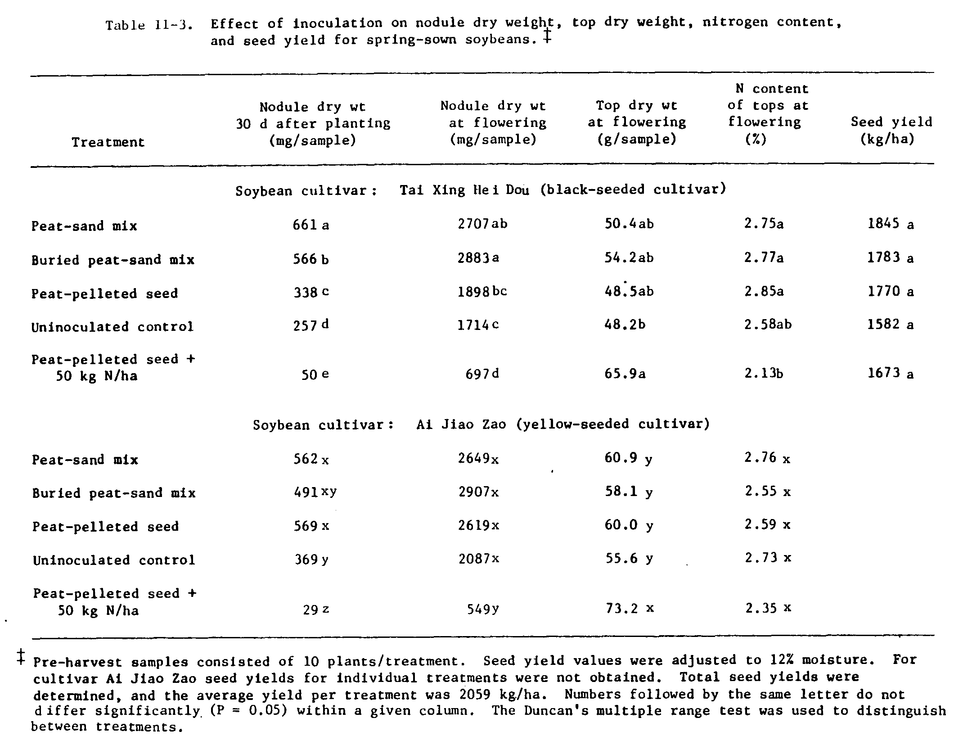
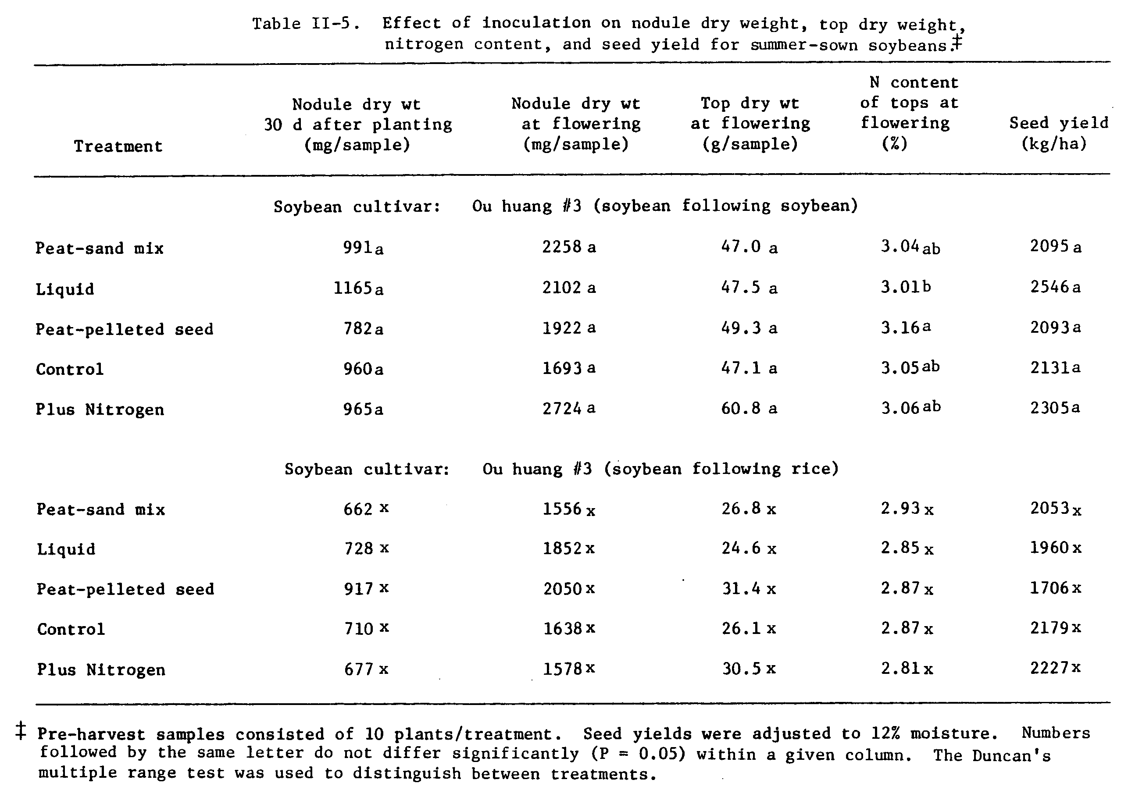
In the soybean-soybean sequence, 005 was less successful and was unable to surpass the indigenous strains in any of the treatments. The other inoculum strain, USDA123, was not a competitive strain in any of the treatments, and was not recovered in any of the nodules on soybeans in the soybean-soybean sequence.
The rhizosphere response of the two inoculum strains, 005 and USDA123, and the indigenous strain reacting with FA USDAl10, was quite different as indicated in Table II-7. In the first sampling, 4 d after inoculation, numbers of both inoculum strains had decreased. By the final sampling, 29 d after inoculation, numbers of one of the inoculum strains, 005, had increased to levels exceeding those at the time of inoculation; whereas numbers of the other inoculum strain, USDA123, had decreased to even lower levels. These patterns were observed for both the liquid and the peat-base inocula, and in both cropping rotations. In the rice-soybean sequence, however, the inoculum strain 005 attained a greater numerical dominance over the indigenous strain than in the soybean-soybean sequence where the indigenous strain and 005 attained similar numbers in the rhizosphere. The other inoculum strain, USDA123, was unable to grow substantially in the rhizosphere in either crop sequence as numbers of USDA123 decreased gradually over time.
The ability of rhizobia to survive in flooded soil is indicated in Table II-8. Survival was not influenced by the rice plant as indicated by the lack of significant differences in the rice-rhizosphere and nonrhizosphere samples. There was an initial decrease in the rhizobial population after flooding. Numbers of rhizobia stabilized at this lower level until the end of the season when there was another decline. There was no evidence of differential survival amongst the indigenous strains, and the lack of occurrence of inoculum strains from the spring-sown soybeans made comparisons between the inoculum and indigenous strains’ ability to survive flooding impossible.
After the summer-sown soybeans, soil samples were collected from each soybean section and the soil was tested for the persistence of rhizobia. Since inoculum strains were recovered with low frequency there was no evidence that inoculation or nodule occupancy had an effect on the persistence of strains in soil following the soybean harvests (Table II-9).

Discussion

In many soils in China competition from indigenous strains of R. japonicum may be an obstacle to improving soybean yields through inoculation. The rice soil used in this experiment, with no prior history of soybean cultivation, is a case in point. Prior to spring planting, soil populations of soybean rhizobia were relatively low. After harvest, in the two sections of the field where soybeans were not planted, rhizobial populations showed similar increases despite the fact that one section was left fallow while the other was flooded during rice cultivation. After the harvest of the summer-sown crops, the rhizobial populations declined in the fallow section. The seasonal fluctuations in the soil populations of rhizobia were similar to the fluctuations Wilson (1930) observed on R. trifolii and R. leguminosarum numbers in soil. Few studies have examined the growth of rhizobia in soil or in the rhizosphere. Rhizobia appear to be good rhizosphere bacteria as evidenced by the large numbers of strains found around the roots of host and non-host species (Rovira, 1961; Pena-Cabriales and Alexander, 1983; Reyes and Schmidt, 1979; Moawad et al., 1984) despite the fact that they make up a small proportion of total bacteria in the rhizosphere (Moawad et al., 1984). In the fallow field, the seasonal changes in numbers of rhizobia may be part of a general response of soil bacteria adjusting to the presence of roots that enhance bacterial development.
In the spring-sown soybeans, the responses to inoculation measured both by nodule mass and nodule occupancy by inoculum strains, were greatest in the inoculation treatments introducing the highest numbers of rhizobia. This confirms earlier reports emphasizing the need for applying high numbers of rhizobia in order to displace indigenous rhizobia (Kapusta and Rouwenhorst, 1974; Weaver and Frederick, 1974; Boonkerd et al., 1978; Bezdicek et al., 1978; Smith et al., 1981).
The two strains in the inoculum in the spring-sown soybeans were 005 and USDA136. Strain 005 was effective on both cultivars, whereas USDA136 was effective on cultivar Tai Xing Hei Dou only (Dowdle and Bohlool, 1985). The responses to inoculation were more pronounced on Tai Xing Hei Dou as measured by nodule mass 30 d after sowing and at flowering, and reflected the variation in inoculum size with more nodule mass in the inoculation treatments introducing the higher numbers of rhizobia. On cultivar Ai Jiao Zao, responses to inoculation were evident only at the early sampling of nodule mass. Although the overall response to inoculation was less on this cultivar, the effective inoculum strain 005 was able to form a significant proportion of the nodules. Unlike Diatloff and Brockwell (1976) who observed a reduction in nodulation by an effective strain when an ineffective strain was included in the inoculum, nodulation on Ai Jiao Zao was seemingly unaffected by the ineffective strain in the inoculum.
At flowering, recovery of the inoculum strains in the nodules of both cultivars was greater for the peat-sand inoculum than for the peat pelleted seed inoculum. In general, the peat-sand inoculum performed better than the peat pelleted seed inoculum. It is not readily apparent whether or not this effect was the result of higher number of cells or of a more favorable placement of the inoculum. It has been pointed out that granular inoculants may be of particular value in certain epigeal species, such as soybeans, that frequently lift the seed coat out of the soil during emergence of the cotyledons (Williams, 1984). Under these circumstances, inoculum placed in the row or below the seed may be closer to the site of nodule initiation and in a more favorable position to compete successfully with indigenous rhizobia. In the buried peat-sand treatment, most of the nodules on the tap roots were formed at or near the depth of inoculation. Wilson (1975) observed a similar pattern of nodule development in a glasshouse study where inoculum was placed at varying depths up to 20 cm below the soil surface. In the present study, nodule mass at the early sampling was negatively influenced by deep placement, whereas at the latter sampling this effect was not apparent. This may have been due to increased nodulation by indigenous strains at the latter sampling. In another study, Hinson (1969) reported that nodule number was essentially equal at placement depths of 4 and 6.5 cm. However, no comparisons were made with inoculum placement at the soil surface.
The inoculum strains for the summer-sown soybeans were 005 and USDA123. Nodule occupancy by the inoculum strains was affected by the crop rotation with higher occupancy in the rice-soybean sequence than in the soybean-soybean sequence. The indigenous population was more than 1000 times higher in the soybean-soybean section of the field at the time of the summer planting than in the rice-soybean section, and the more favorable ratio of inoculum to indigenous rhizobia in the latter section may have been one of the determinant factors in competition between indigenous and inoculant rhizobia.
The pattern of responses of the inoculum strains and an indigenous strain in the soybean rhizospheres were distinctly different. In both crop sequences the indigenous strain showed gradual or little growth during the sampling period. The numbers of both the inoculum strains, on the other hand, declined after inoculation followed by increased numbers of 005 and decreased numbers of USDA123. The greater numerical dominance of 005 in rhizospheres in the rice-soybean section versus the soybean-soybean section may be the result of the smaller indigenous population in the rice-soybean section at planting.
In much of the soybean growing area in the north central U.S. indigenous strains of R. japonicum serogroup 123 dominate nodulation of soybeans (Damirgi et al., 1967; Ham et al., 1971b). Strain characteristics that confer competitive advantage to 123 remain unknown. Moawad et al. (1984) examined soybean rhizosphere growth of strain 123 and two other indigenous strains and concluded that the competitive success of 123 was not related to an ability to outgrow other indigenous rhizobia in the host rhizosphere. Kosslak and Bohlool (1985) did competition studies in two soils devoid of R. japonicum and reported that 123 was a poor competitor in those soils. In this study, 123 did not grow well in the soybean rhizospheres after being introduced into the soil and was a poor competitor in forming nodules, whereas strain 005 grew well and was a good competitor for nodule sites. The relationships between growth in the rhizosphere and competition for nodule sites are not well understood and more studies are needed.
The assessment of the need to re-inoculate soybeans following rice has not received adequate attention. Wu et al. (1968) concluded that despite the fact soybean rhizobia seem to survive well in flooded soils each soybean crop following flooded rice should be re-inoculated. From the results of this study, there is reason to believe that if the indigenous rhizobia had been ineffective, then inoculation of soybeans following rice would have resulted in increased effective nodulation.
The ability of R. japonicum to survive in flooded soils was manifest in several ways. The increase in numbers of rhizobia in the soil following the spring-sown rice, and the high numbers in the soil following rice in the soybean-rice sequence indicated that flooding the soil did not have a significant negative impact on the numbers of rhizobia in the soil. The rice plant apparently did not influence the rhizobial population as evidenced by the same response in the rice rhizosphere and non-rhizosphere soil. Rhizobium sp. are generally considered to be aerobic organisms (Jordan, 1984) utilizing oxygen as the terminal electron acceptor, and mechanisms of anaerobic growth are relatively uncharacterized. Daniel et al. (1980) examined anaerobic growth of R. japonicum strain 505 and showed the strain was capable of growing under anaerobic conditions by nitrate respiration with the final product being N₂0. They suggested that free living rhizobia may remove fixed nitrogen from the soil by denitrification. The potential influence this may have on the nitrogen status of paddy soils deserves further investigation. It is not known whether or not the indigenous R. japonicum in rice soils China are characteristically well adapted to free living anaerobic growth. In this study, differential survival of inoculum and indigenous strains was not observed because of the low recovery of the inoculum strain throughout the sampling period.
The release and establishment of inoculum strains in the soil following soybean cultivation was not detected in this study. Following the harvest of the summer-sown soybeans, soil samples collected from the experimental plots and subsequent analysis of nodule occupancy on soybeans grown in these soil samples failed to reveal a significant presence of the strains which were in the previous inoculum. It has been shown that decaying nodules release high numbers of rhizobia into the soil (Moawad et al., 1984;) but what influence this may have on subsequent rhizobia establishment and persistence in the soil is unknown. There was no difference in the recovery of strain 005 in soils collected from the soybean-soybean section and in soils collected from the rice-soybean section despite the fact that 005 was inoculated into the soybean-soybean section twice and inoculated into the rice-soybean section only once.
Literature Cited

Abel, G.H., and L.W. Erdman. 1964. Response of Lee soybeans to different strains of R. japonicum. Agron. J. 56:423-424.

Bezdicek, D.F., D.W. Evans, B. Abede, and R.E. Witters. 1978. Evaluation of peat and granular inoculum for soybean yield and N fixation under irrigation. Agron. J. 70:865-868.

Bohlool, B.B., and E.L. Schmidt. 1968. Nonspecific staining: its control in immunofluorescence examination of soil. Science 162:1012-1014.

Bohlool, B.B., and E.L. Schmidt. 1973. Persistance and competition aspects of Rhizobium japonicum observed in soil by immunofluorescence microscopy. Soil Sci. Soc. Am. Proc. 37:561-564.

Boonkerd, N., D.F. Weber, and D.F. Bezdicek. 1978. Influence of Rhizobium japonicum strains and inoculation methods on soybeans grown in rhizobia-populated soil. Agron. J. 70:547-549.

Burton, J.C., and R.L. Curley. 1965. Comparative efficiency of liquid and peat-base inoculants on field grown soybeans (Glycine max). Agron. J. 57:379-381.

Caldwell, B.E., and G. Vest. 1970. Effects of Rhizobium japonicum strains on soybean yields. Crop Sci. 10:19-21.

Damirgi, S.M., L.R. Frederick, and I.C. Anderson. 1967. Serogroups of Rhizobium japonicum in soybean nodules as affected by soil types. Agron. J. 59:10-12.

Daniel, R.M., I.M. Smith, J.A.D. Phillip, H.D. Ratcliffe, J.W. Drozd, and A.T. Bull. 1980. Anaerobic growth and denitrification by Rhizobium japonicum and other rhizobia. J. Gen. Microbiol. 120:517-521.

De-Polli, H., A.A. Franco, and J. Dobereiner. 1973. Sobrevivencia de Rhizobium em solos de baixada sujeitos a inundacao. Pesqui. Agropecu. Bras. Ser. Agron. 8:133-138.

Diatloff, A., and J. Brockwell. 1976. Symbiotic properties of Rhizobium japonicum and competitive success in nodulation of two Glycine max cultivars by effective and ineffective strains. Aust. J. Exp. Agric. Anim. Hus. 16:514-521.

Dowdle, S.F., and B.B. Bohlool. In review. Predominance of fast-growing Rhizobium japonicum in a soybean field in the People’s Republic of China. Appl. Environ. Microbiol.

Elkins, D.M., G. Hamilton, C.K.Y. Chan, M.A. Briskovich, and J.W. Vandeventer. 1976. Effect of cropping history on soybean growth and nodulation and soil rhizobia. Agron. J. 68:513-517.

Gibson, A.H. 1963. Physical environment and symbiotic nitrogen fixation. I. The effect of root temperature on recently nodulated Trifolium subterraneum L. plants. Austral. J. Biol. Sci. 16:28-42.

Ham, G.E., V.B. Cardwell, and H.W. Johnson. 1971a. Evaluation of Rhizobium japonicum in soils containing naturalized populations of Rhizobia. Agron. J. 63:301-303.

Ham, G.E., L.R. Frederick, and I.C. Anderson. 1971b. Serogroups of Rhizobium japonicum in soybean nodules sampled in Iowa. Agron. J. 63:69-72.

Hinson, K. 1969. Alternatives to seed-packet inoculation of soybeans with Rhizobium japonicum. Agron. J. 61:683-686.

Hunter, M.N., P.L.M. de Fabrun, and D.E. Byth. 1980. Response of nine soybean lines to soil moisture conditions close to saturation. Aust. J. Exp. Agric. Anim. Husb. 20:339-345.

Hymowitz, T., and C.A. Newell. 1981. Taxonomy of the genus Glycine, domestication, and uses of soybeans. Econ. Botany 35:272-288.

Jordan, D.C. 1984. Family III. Rhizobiaceae, p.234-257. In N.R. Krieg and J.G. Holt (eds.), Bergey’s manual of systematic bacteriology, Vol. 1. The Williams and Wilkins Co., Baltimore.

Jensen, H.L. 1942. Nitrogen fixation in leguminous plants. I. General characters of root-nodule bacteria isolated from species of Medicago and Trifolium in Australia. Proc. Linn. Soc. N.S.W. 66:98-108.

Johnson, H.W., U.M. Means, and C.R. Weber. 1965. Competition for nodule sites between strains of Rhizobium japonicum applied as inoculum and strains in the soil. Agron. J. 57:179-185.

Kapusta, G., and D.L. Rouwenhorst. 1973. Influence of inoculum size on Rhizobium japonicum serogroup distribution frequency in soybean nodules. Agron. J. 65:916-919.

Kingsley, M.T., and B.B. Bohlool. 1981. Release of Rhizobium spp. from tropical soils and recovery for immunofluorescence enumeration. Appl. Environ. Microbiol. 42:241-248.

Kosslak, R.M., and B.B. Bohlool. 1985. Influence of environmental factors on interstrain competition in Rhizobium japonicum. Appl. Environ. Microbiol. 49:000-000.

Kvien, C.S., G.E. Ham, and J.W. Lambert. 1981. Recovery of introduced Rhizobium japonicum strains by soybean genotypes. Agron. J. 73:900-905.

Lowendorf, H.S. 1980. Factors affecting survival of Rhizobium in soil, p.87-124. In M. Alexander (ed.), Advances in Microbial Ecology. Plenum Press, New York.
Lynch, D.L., and O.H. Sears. 1952. The effect of inoculation upon yields of soybeans on treated and untreated soils. Soil Sci. Soc. Am. Proc. 16:214-216.

Miles, A.A., and S.S. Misra. 1938. The estimation of the bacteriocidal power of blood. J. Hyg. Camb. 38:732-749.

Moawad, H.A., W.R. El l is, and E.L. Schmidt. 1984. Rhizosphere response as a factor in competition among three serogroups of indigenous Rhizobium japonicum for nodulation of field-grown soybeans. Appl. Environ. Microbiol. 47:607-612.

Norman, A.G. 1942. Persistence of Rhizobium japonicum in soil. J. Am. Soc. Agron. 34:499.

Osa-Afiana, L.O., and M. Alexander. 1979. Effect of moisture on the survival of Rhizobium in soil. Soil Sci. Soc. Am. J. 43:925-930.

Pena-Cabriales, J.J., and M. Alexander. 1983. Growth of Rhizobium in unamended soil. Soil Sci. Soc. Am. J. 47:81-84.

Reyes, V.G., and E.L. Schmidt. 1979. Population densities of Rhizobium japonicum strain 123 estimated directly in soil and rhizospheres. Appl. Environ. Microbiol. 37:854-858.

Rovira, A.D. 1961. Rhizobium numbers in the rhizosphere of red clover and paspalum in relation to soil treatment and numbers of bacteria and fungi. Aust. J. Agric. Res. 12:77-83.

Schmidt, E.L., R.O. Bankole, and B.B. Bohlool. 1968. Fluorescent antibody approach to the study of rhizobia in soil. J. Bacteriol. 95:1987-1992.

Smith, R.S., M.A. Ellis, and R.E. Smith. 1981. Effect of Rhizobium japonicum inoculant rates on soybean nodulation in a tropical soil. Agron. J. 73:505-508.

Vincent, J.M. 1970. A manual for the practical study of root- nodule bacteria. IBP handbook 15. Blackwell Scientific Publications, Oxford.

Weaver, R.W., L.R. Frederick, and L.C. Dumenil. 1972. Effect of soybean cropping and soil properties on number of Rhizobium japonicum in Iowa soils. Soil Sci. 114:137-141.

Weaver, R.W., and L.R. Frederick. 1974. Effect of inoculum rate on competitive nodulation of Glycine max (L.) Merr. II. Field studies. Agron. J. 66:233-236.

Williams, P.M. 1984. Current use of legume inoculant technology p.173-200. In M. Alexander (ed.), Biological Nitrogen Fixation Ecology, Technology, and Physiology. Plenum Press, New York.

Wilson, D.O. 1975. Nitrogen fixation by soybeans as influenced by inoculum placement: greenhouse studies. Agron. J. 67:76-78.

Wilson, J.K. 1930. Seasonal variation in the numbers of two species of Rhizobium in soil. Soil Sci. 30:289-296.

Wu, M.H., S.T. Lee, and M.H. Chiang. 1968. Effects of submerged paddy soil on the life of soybean rhizobia. J. Agric. Assoc. China (New Series) 64:13-17.
CHAPTER III
PREDOMINANCE OF INDIGENOUS FAST-GROWING RHIZOBIUM JAPONICUM
IN A SOYBEAN FIELD IN THE PEOPLE’S REPUBLIC OF CHINA

Abstract

Soybean rhizobia were isolated from two soils with different cropping histories from Hubei province in central China. The first, from Honghu county, had been under soybean cultivation for decades. All of the isolates obtained from nodules on soybeans growing in this soil were fast-growing, acid-producing rhizobia. However, slow-growing, alkaline-producing isolates were obtained at higher dilutions of the same soil. The second soil, from Wuchang county, had been under rice cultivation with no record of previous soybean cultivation. All of the soybean rhizobia recovered from this soil, and at higher dilutions of the soil, were typical slow-growing, alkaline-producing isolates. The isolates from both soils were grouped using intrinsic antibiotic resistance, gel-immunodiffusion, and fluorescent antibody procedures. Representative isolates were tested for symbiotic effectiveness with four soybean cultivars (Peking, Davis, Williams, and Ai Jiao Zao) in a pot experiment. There were significant cultivar-rhizobia interactions. Moreover, on each cultivar, there was at least one fast-growing isolate among these new rhizobia that was as effective as the highly effective, slow-growing reference strain USDAl10.

Introduction

Bacteria of the genus Rhizobium nodulate and fix nitrogen in symbiosis with many legumes. The various species in this genus comprise two broad groups of fast-and slow-growing strains based on growth rate and effect on the pH of yeast extract mannitol (YEM) medium (Jordan and Allen, 1974; Vincent, 1974). Citing these and other fundamental differences the slow-growing strains were transfered to a newly named genus (Bradyrhizobium gen. nov.), while the fast growers were retained in the genus Rhizobium (Jordan, 1984). This new taxonomy, however, does not readily accommodate fast-growing soybean rhizobia.
Soybeans are considered to be commonly nodulated by slow-growing rhizobia only. Recently, Keyser et al. (1982) reported fast-growing strains of rhizobia isolated from soybean root nodules collected in the People’s Republic of China. Studies have shown these fast-growing soybean rhizobia to be distinct in their microbiological and symbiotic properties from the ‘typical’ slow-growing types (Sadowsky et al., 1983; Stowers and Eaglesham, 1984; Keyser et al., 1985).
Initial studies on the symbiotic effectiveness of the fast growers set forth the notion that they are effective only with certain soybean genotypes from Asia but are generally ineffective with several N. American adapted soybeans (Keyser et al., 1982). Subsequent studies revealed greater diversity in the symbiotic response between fast growers and soybean cultivars (Van Rensburg et al., 1983; Hattori and Johnson, 1984; Stowers and Eaglesham, 1984) with fast growers forming effective symbioses with several commercial soybean cultivars.
Since China is the center of origin of soybeans (Hymowitz and Newell, 1981), and presumably of its rhizobia, studies in China of the composition of indigenous populations of soybean rhizobia are particularly important. Since one of us (SFD) was in China for 16 months, we had the opportunity to compare the indigenous populations in two soils with different cropping histories. In this study we show that although effective, slow-growing soybean rhizobia were present in relatively high numbers, the majority of nodules were formed by fast-growing rhizobia.

Materials and methods

Soils. The two soils, both located in Hubei province in central China, had markedly different cropping histories. The first, Honghu soil, from Honghu county had been under soybean cultivation without inoculation for as long as people could recall. The second, Wuhan soil, from Wuchang county, had been under continuous rice cultivation with no record of prior soybean cultivation. Soil analyses were kindly done by Ada Chu, of the Benchmark Soils Project, Univ. Hawaii. The following procedures (Soil Conservation Service, 1984) were used: Carbon, 6Ala; Total N, 6Bl; Fe, 6Cl; P, Olsen; Cations, 5Al; pH-H₂0 and KCl, 1:1 suspension and 1 h equilibration. The chemical properties of the soils were similar except for soil pH (Table III-1).
Soybean cultivars. Five soybean (Glycine max L. Merr.) cultivars were used in this study. Ou Huang #3 and Ai Jiao Zao are improved, yellow-seeded cultivars released by the Oils and Root Crops Institute in Wuhan for use in Hubei Province. Ai Jiao Zao was the cultivar planted in Honghu where the Honghu soil was collected. Peking is an unimproved black seeded cultivar. Davis and Williams are common commercial cultivars in North America.
Isolation of rhizobia. Cultivar Ou Huang #3 was used as the trap host. The methodology for isolation was devised in order to obtain a heterogeneous population of indigenous rhizobia. Since the soils had been in cold storage, the rhizobia population was stimulated by growing soybeans. After ten days the seedlings were removed. Rhizosphere soil was collected by carefully removing the seedlings, gently shaking the intact root system to remove soil loosely adhering to the roots, and placing the root system with the remaining soil adhering to the roots in 100 ml YEM salts (Vincent, 1970). The rhizosphere soil suspensions were shaken for 15 min on a wrist action shaker. Five ten-fold serial dilutions of the suspensions were made and 1 ml of each dilution was added soybeans planted in sterile vermiculite. In addition, soybeans were planted directly in the enriched soil. Eight nodules from each dilution were collected and used to isolate rhizobia. Nodules were rinsed extensively in tap
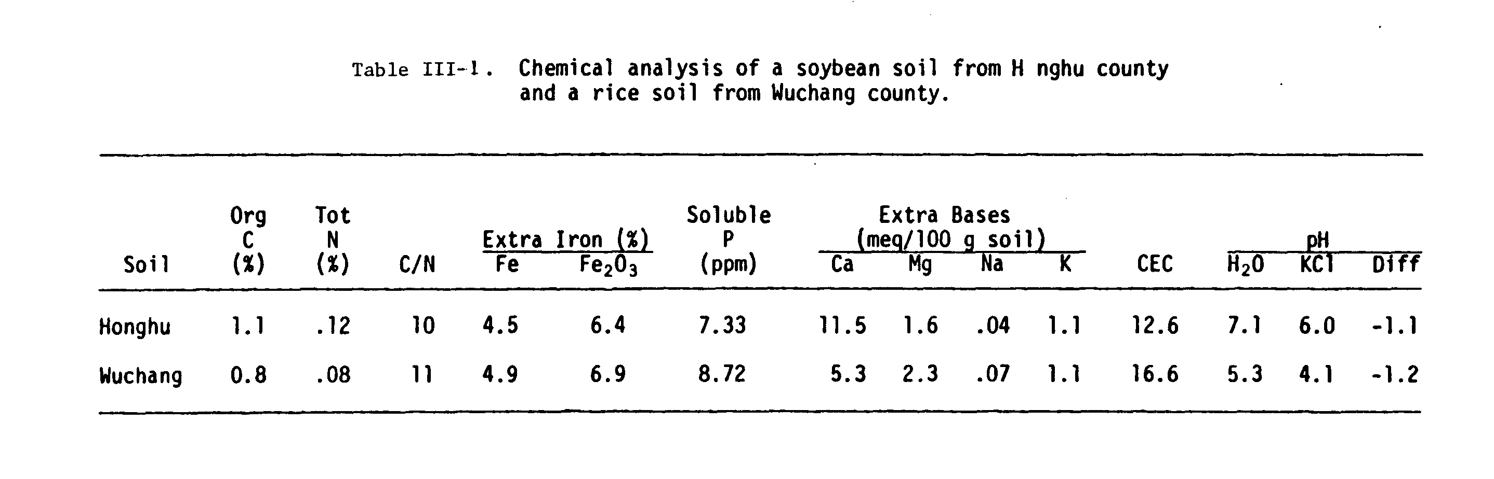
water, immersed in 95% EtOH for 20 seconds, and immersed in 4% H₂O₂ for 4 minutes. Nodules were crushed in 2 ml of YEM salts. Ten-fold serial dilutions of the nodule crushate were made and 0.1 ml of the appropriate dilutions were spread on YEM agar plates containing 0.25 mg bromthymol blue per liter and 20 mg actidione per liter.
Purification, authentication, and cataloguing. For each nodule isolate, a single colony was selected and re-streaked on YEM agar plates and checked for purity. Once pure cultures were confirmed, each isolate was streaked on YEM agar plates containing congo red (Vincent, 1970). Each isolate was confirmed to be soybean rhizobia by inoculating Glycine soja seedlings growing in test tubes with Hoagland’s plant nutrient agar (Hoagland and Arron, 1938). All isolates were maintained on YEM agar slants; the agar slants used for the maintenance of fast-growing isolates contained 0.05% CaCO₃. Isolates were catalogued as follows: isolates with the prefix HH were isolated from the Honghu soil; isolates with the prefix WU were isolated from the Wuhan soil; isolates with the initial number of ‘0’ were isolated from plants grown directly in the soil; isolates with the initial number of ‘1’ were isolated from the 10⁻¹ dilution of the rhizosphere soil; isolates with the initial number of ‘2’ were isolated from the 10⁻² dilution of the rhizospere soil; and so on. Thus HH504 is an isolate from the 10⁻⁵ dilution of the Honghu rhizosphere soil.
Generation times. Growth and pH responses were determined in YEM and Bishop’s (Bishop et al., 1976) media for 3 fast-growing isolates: USDA205, HH103, and HH303; and 3 slow-growing isolates: USDA110, WU002, and WU006. USDA205 is one of the fast-growing soybean rhizobia isolated previously (Keyser et al., 1982); HH103 and HH303 are fast-growing soybean rhizobia isolated from the Honghu soil. USDA110 is a slow-growing strain from the USDA Culture Collection, Beltsville, Maryland; WU002 and WU006 are slow-growing soybean rhizobia isolated from the Wuhan soil. Both media were adjusted to pH 6.9 prior to inocultion. Fast-growing isolates were pre-grown in each medium for 3 days, while slow-growing isolates were pre-grown for 5 days. Inocula were added to an initial density of 10⁶ cells per ml into 50 ml of the medium in 125 ml “side-arm” Erlenmeyer flasks. Flasks were agitated at 25⁰C in a water-bath shaker. Cell growth was monitored using a Klett-Summerson Photoelectric Colorimeter (equipped with a # 66 red filter) and pH was determined after four days using an Orion Research (model 501) pH meter and a glass combination electrode.
Intrinsic antibiotic resistance (IAR). Resistance to low levels of antibiotics was determined by the method of Josey et al. (1979). Fresh solutions of antibiotics (obtained from Sigma) were filter sterilized
(0.4 um Nuclepore) and added to cooled (48⁰C) YEM agar medium to give the following concentrations (ug/ml): chloramphenicol (Chl), 12 and 25; kanamycin sulfate (Kan), 10; naladixic acid (Nal), 10; neomycin sulfate (Neo), 2.5; polymixin B sulfate (Pol), 20; rifampicin (Rif), 1 and 6; streptomycin sulfate (Str), 2.5 and 10; tetracycline hydrochloride (Tet), 1; and vancomycin (Van), 1.5 and 5. Antibiotic stock solutions were prepared in sterile distilled water at a concentration of 10 mg/ml, except Chi (10 mg/ml in 95% ethanol), Nal (10 mg/ml in 1N NaOH), and Rif (10 mg/ml in methanol). The use of a multiple inoculator allowed for simultaneous inoculation of up to 28 cultures per petri plate. Each culture was replicated four times per antibiotic concentration used. Controls consisted of YEM agar plates without antibiotics. Duplicate plates of each antibiotic concentration were incubated in the dark for 7 d and isolates showing growth were scored as positive.
Immunofluorescence. Fluorescent antibodies (FAs) were prepared from sera against the somatic components of soybean rhizcbia strains according to the procedures of Schmidt et al. (1968). Gelatin-rhodamine isothiocyanate (Bohlool and Schmidt, 1968) was used to suppress nonspecific adsorption. The microscopy techniques have been described elsewhere (May and Bohlool, 1983).
Immunodiffusion (ID). Immunodiffusion procedures have been described elsewhere (Kingsley and Bohlool, 1983). Antigens for immunodiffusion analyses were prepared from cells grown on the surface of B5 medium (Gamborg, 1975). Cells were harvested from agar flats after 3 d of growth, resuspended in 0.85% saline containing Thimerosal (1:10,000 final conc.), and stored at 40⁰C until use. Gels were incubated for 6 d in a moist, dark chamber at room temperature, rinsed exhaustively for several days with frequent changes of 0.85% saline solution, stained with amido black ( 0.1% amido black, 4.25x10⁻¹M acetic acid, 4.25x10⁻²M sodium acetate, and 15% glycerol), and destained with 2.0% acetic acid for several days until the background was clear. The precipitin bands were recorded photographically.
Host range and symbiotic efficiency. Seeds were surfaced sterilized, Vigna unguiculata, in 4% calcium hypochlorite, 20 min; Sesbania cannabina PI180050, in conc. H₂SO₄, 20 min; Macroptilium atropurpureum, in conc. HCl, 3 min; and planted in sterile vermiculite moistened with 1:4 strength Hoagland’s nitrogen-free solution in Leornard jars. Five-day-old seedlings were inoculated with the desired strains and the top of the vermiculite was covered with sterile perlite and a layer of paraffin-coated sand. There were three replicates per treatment. Plants were harvested 5 weeks after inoculation.
A glasshouse pot study was designed to evaluate the symbiotic efficiency of selected isolates on 4 soybean cultivars (Ai Jiao Zao, Davis, Peking, and Williams). A mixture of sand, perlite, and vermiculite (1:1:1 by vol) was placed in 3 gal pots (25 cm diam) lined with plastic bags. The pots were divided into 4 sections with two, 20 cm sheets of fiberglass extending to the bottom of the pots. A 20 cm (10 mm diam) PVC pipe in the center of the pots also extending to the bottom of the pots facilitated watering with 1/4 strength Hoagland’s nitrogen-free solution.
Seeds were surface sterilized for 20 min in 4% calcium hypochlorite, washed extensively in sterile water, and 4 seeds of each cultivar were planted in each pot. Three-day-old seedlings were thinned to leave one seedling of uniform size of each cultivar per pot. The four seedlings in each pot were inoculated with the same isolate of rhizobia by adding 1 ml of the turbid culture to each seedling. After inoculation, the top of the sand-perlite-vermiculite mixture was covered with a 3 cm layer of fine gravel. There were three replicates for each treatment. Plants were harvested 4 weeks after inoculation. Plant tops were dried at 70⁰C, weighed, and nitrogen content was determined by Kjeldahl analysis.

Results

The method used to enrich and isolate rhizobia from the two soils yielded a heterogeneous population of indigenous rhizobia (Table III-2). In the Honghu soil, which had a long history of soybean cultivation, fast-growing isolates were predominant. Moreover, different isolates (i.e. belonging to different IAR groups and having different gel ID patterns) were obtained at the various dilutions of the rhizosphere soil. Slow-growing isolates were also recovered in high numbers as indicated by their recovery at the higher dilutions of the rhizosphere soil. In the Wuhan rice soil, with no prior record of soybean cultivation, only slow-growing isolates were recovered. The slow-growing isolates were tested for serological affinity using strain-specific fluorescent antibodies. Nearly 100% of the isolates from the Wuhan soil could be identified using 3 FAs: FA USDAl10, FA CB1809, and FA USDA31. The slow-growing isolates from the Honghu soil did not react with any of the 13 FAs tested.
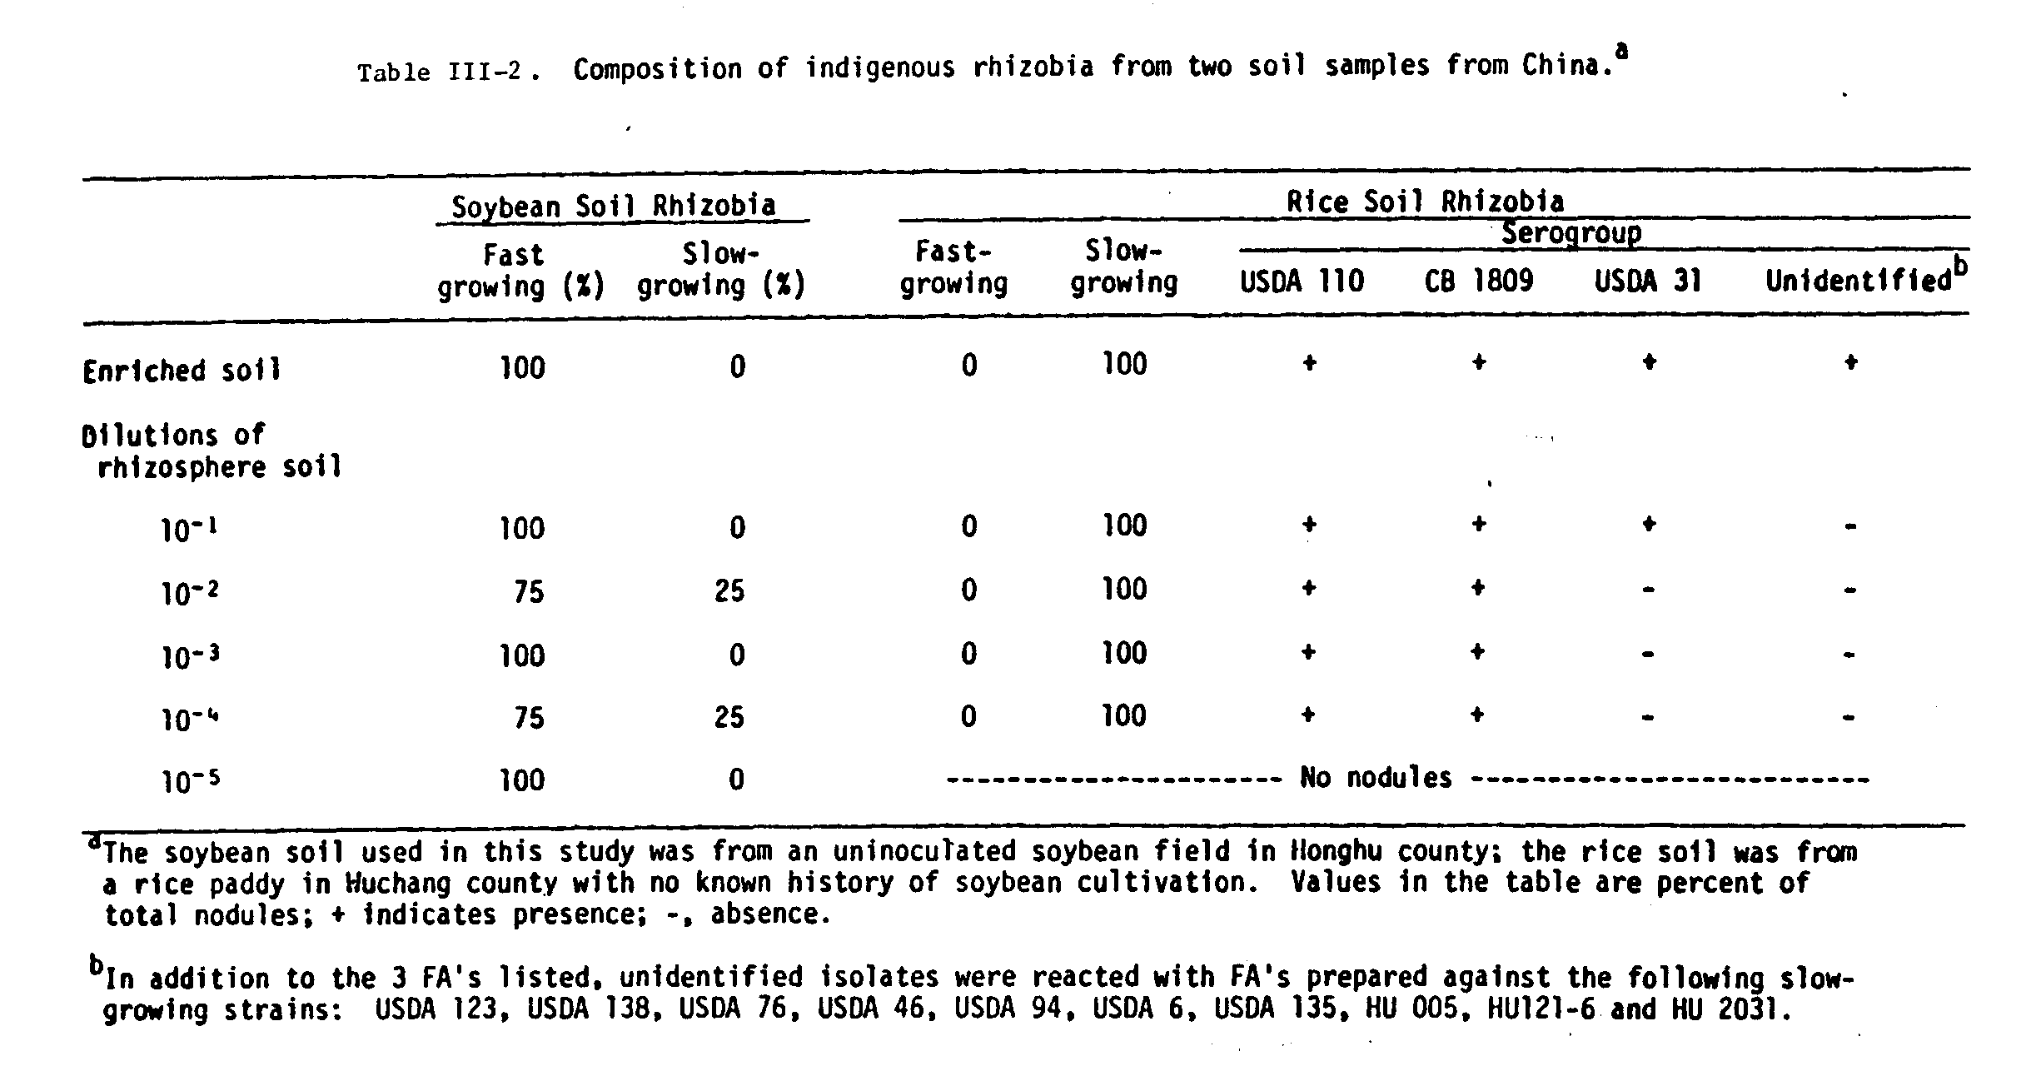
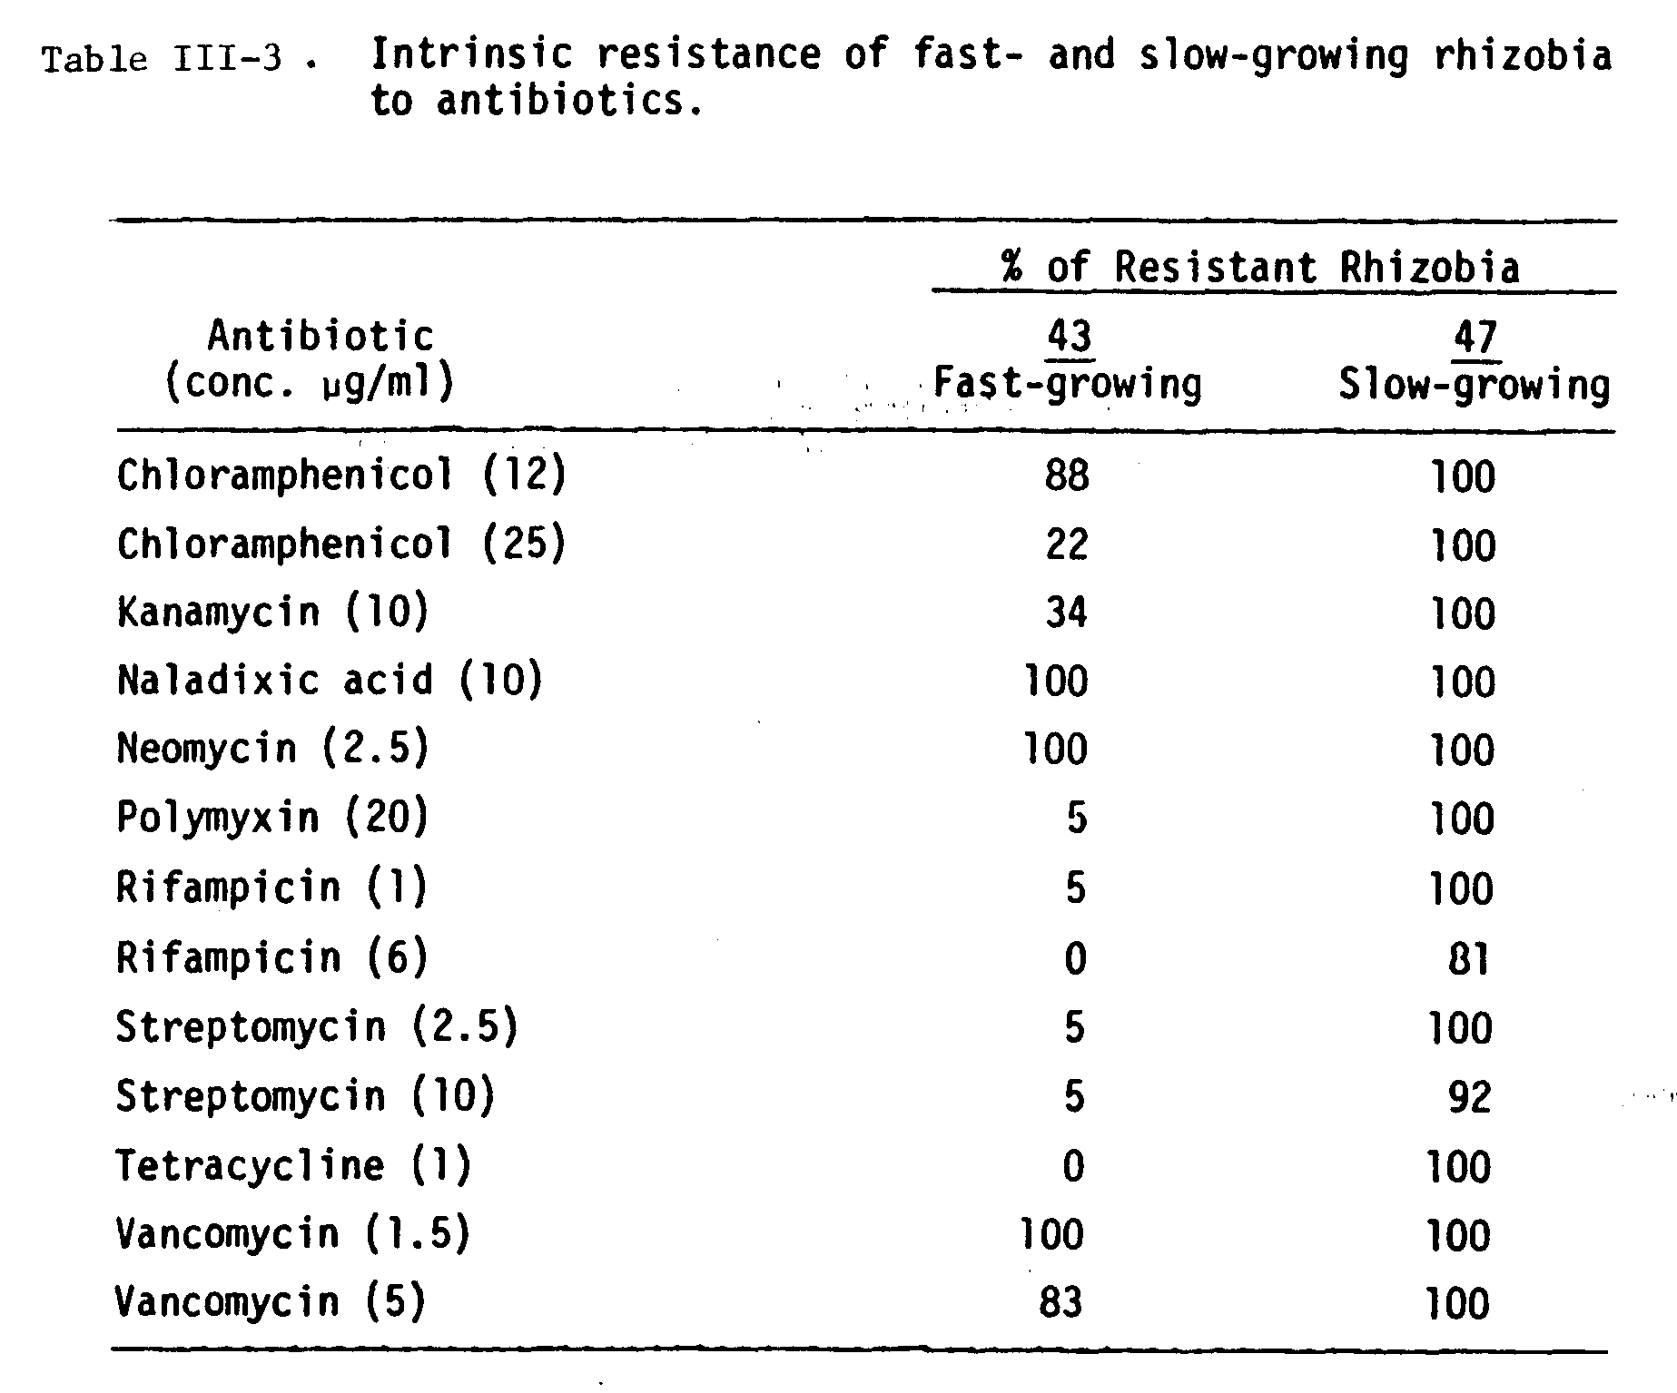
The fast-growing isolates were grouped according to their intrinsic resistance to low levels of antibiotics (Table III-3). There were 8 patterns of antibiotic resistance among the fast growers (Table III-4). The differences detected among the slow-growing isolates were primarily due to the slow-growing isolates from the Honghu soil.
The results of immunodiffusion cross-reactions of two fast-growing isolates from each IAR pattern with somatic cell antisera produced against fast-growing soybean rhizobia strains USDA192, 194, and 205 are summarized in Table III-5. The reactions with somatic antisera indicated serological relatedness between some of the Honghu isolates and the USDA fast-growing strains reported previously. Of the 15 isolates tested, 7 formed at least one precipitin band with antisera produced against USDA205, two isolates formed one band with USDA194, while the remaining isolates formed no bands. The reactions with whole-cell antisera (data not shown) could not be used to separate the isolates into serogroups, because all of the isolates shared several heat labile antigens.
Two slow-growing isolates, WU002 and WU006 which cross react with FA CB1809 and FA USDAl10, respectively, and two fast-growing isolates, HH103 and HH303, were selected and mean generation times were determined in two media (Table III-6). One known slow-growing strain, USDA110, and one known fast-growing strain USDA205, were included as reference strains. In complex media (YEM) the fast-growing isolates had mean generation times 3 to 4 times lower than the slow-growing isolates, while in a defined medium (Bishop’s) they were 4 to 5 times lower. The fast growers acidified both media while the slow growers made both media more alkaline.
The three fast growers tested were able to nodulate Vigna unguiculata, Macroptilium atropurpureum, and Sesbania cannabina, but were only effective on Vigna sp. and Macroptilium sp. (Table III-7). Moreover, there were significant host-isolate interactions further indicating the heterogeneity of this group of
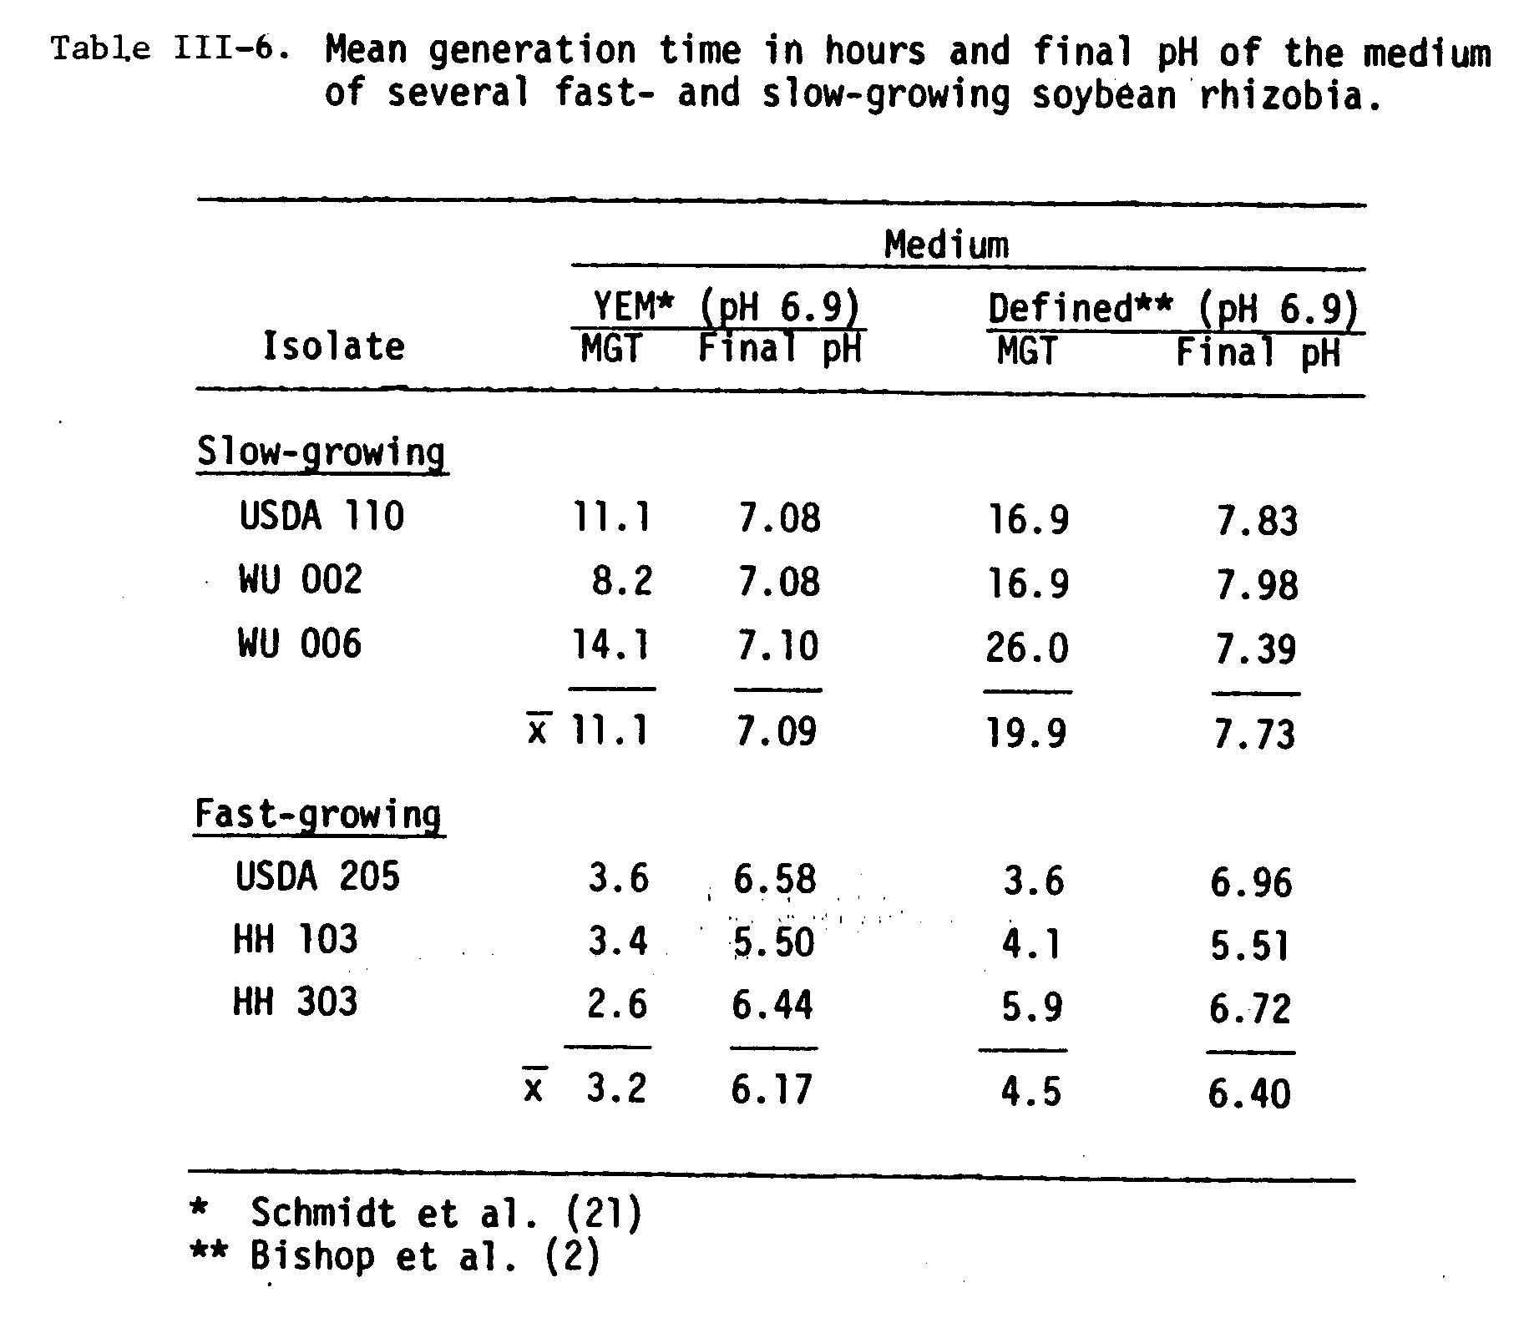
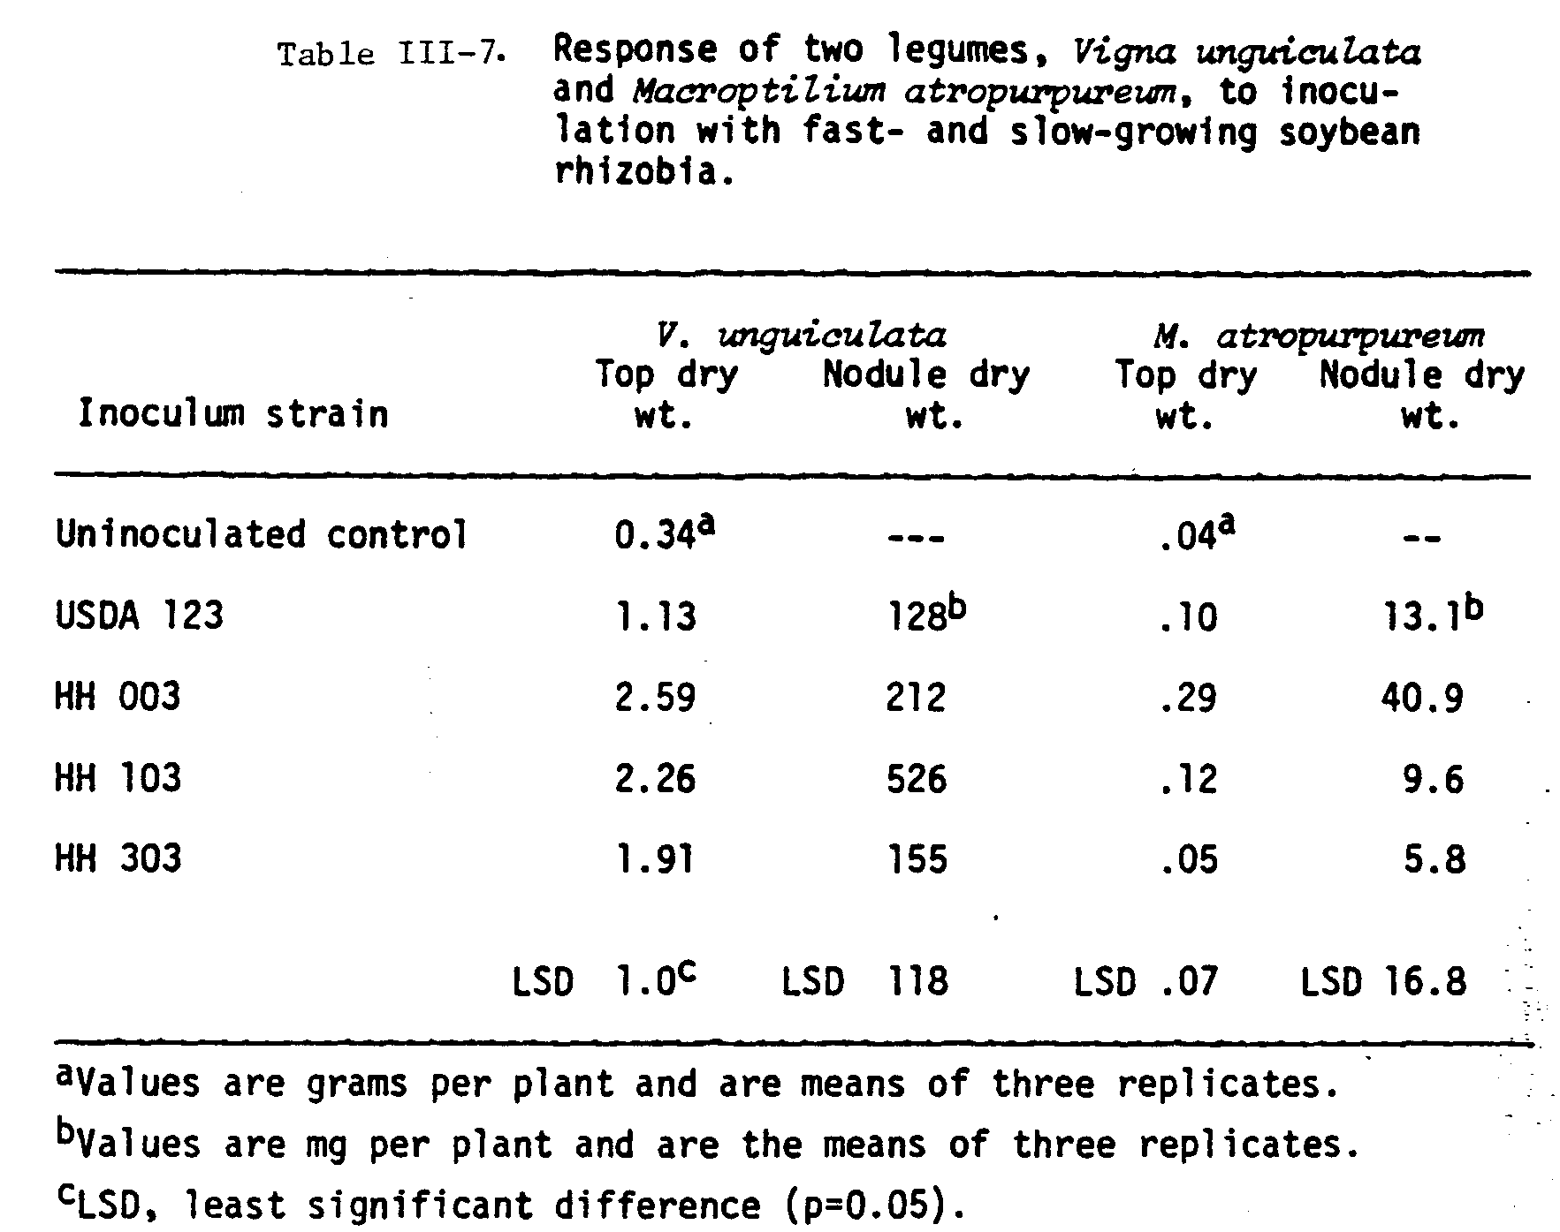
fast-growing rhizobia.
The response of four soybean cultivars to inoculation with fast-and slow-growing isolates are presented in Tables III-8 and III-9. There were significant cultivar-strain interactions. Among the slow growers from the rice soil, one of the predominant isolates, WU002, formed an ineffective symbiosis with cultivar Ai Jiao Zao. One slow-growing isolate, HH401, from the soybean soil formed effective nodules on the cultivar Peking but induced rhizobiotoxin-like symptoms on the leaves which resulted in reduced plant weight. The fast growers were highly effective on the two cultivars from China, Peking and Ai Jiao Zao, whereas they were generally less effective on the two North American cultivars, Williams and Davis. It is important to note, however, that on each cultivar tested there was at least one fast-growing isolate that was as effective as the highly effective slow-growing reference strain USDAl10.

Discusion

The methodology used to isolate rhizobia from soil was similar to a method used by Belser and Schmidt (1978) to isolate ammonia-oxidizing nitrifiers. They obtained different genera of nitrifiers at different dilutions of the soil. In our study, slow-growing rhizobia were recovered in the soybean soil at higher dilutions presumably because the soil factors contributing to competitiveness were less emphatic. The advantage of this methodology for analyzing the composition of an indigenous population is that bacteria are recovered independently of their competitive ability. Initial sampling of nodules from soybeans growing in the Honghu field revealed 100% of the nodules contained fast-growing rhizobia (data not shown), indicating the recovery of fast-growing rhizobia in this study was not peculiar to our methodology.
The fast-growing soybean rhizobia reported previously (Keyser et al.,
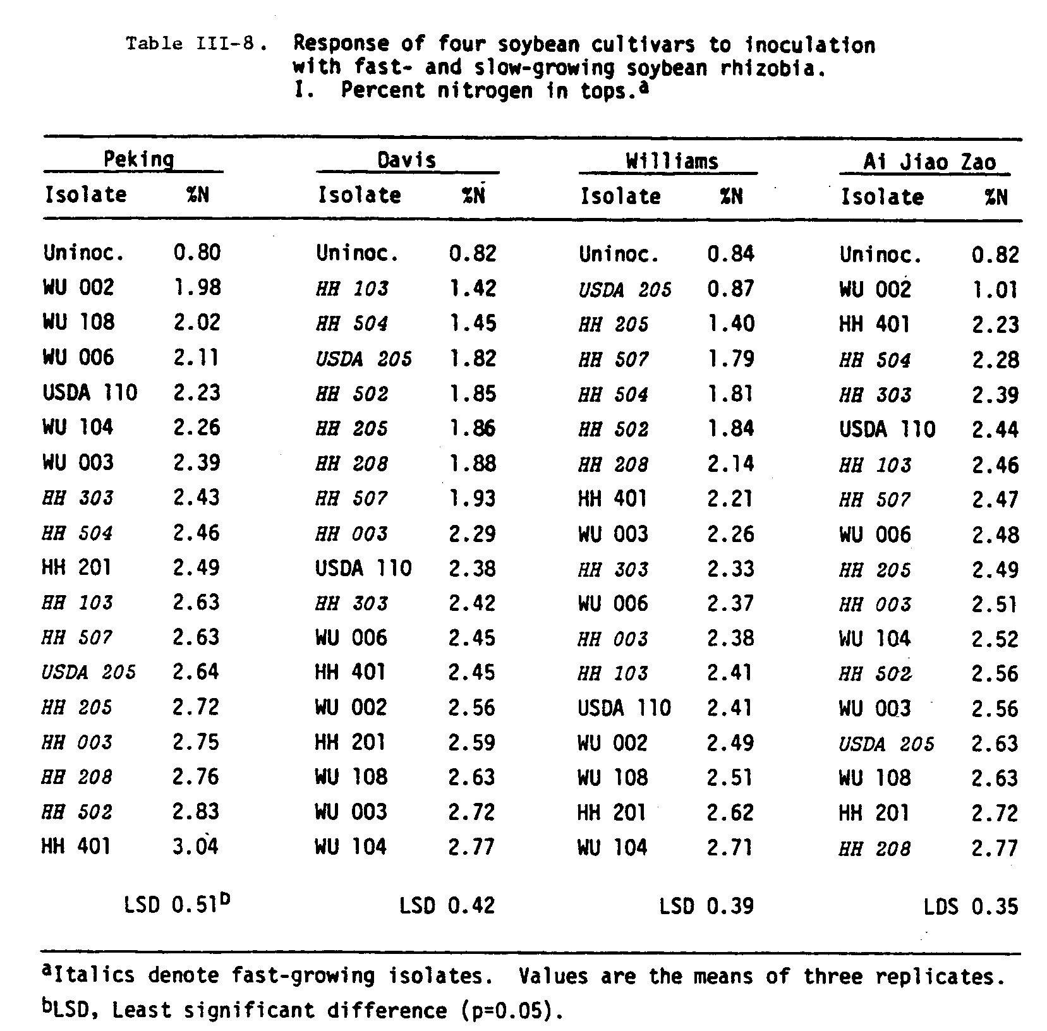
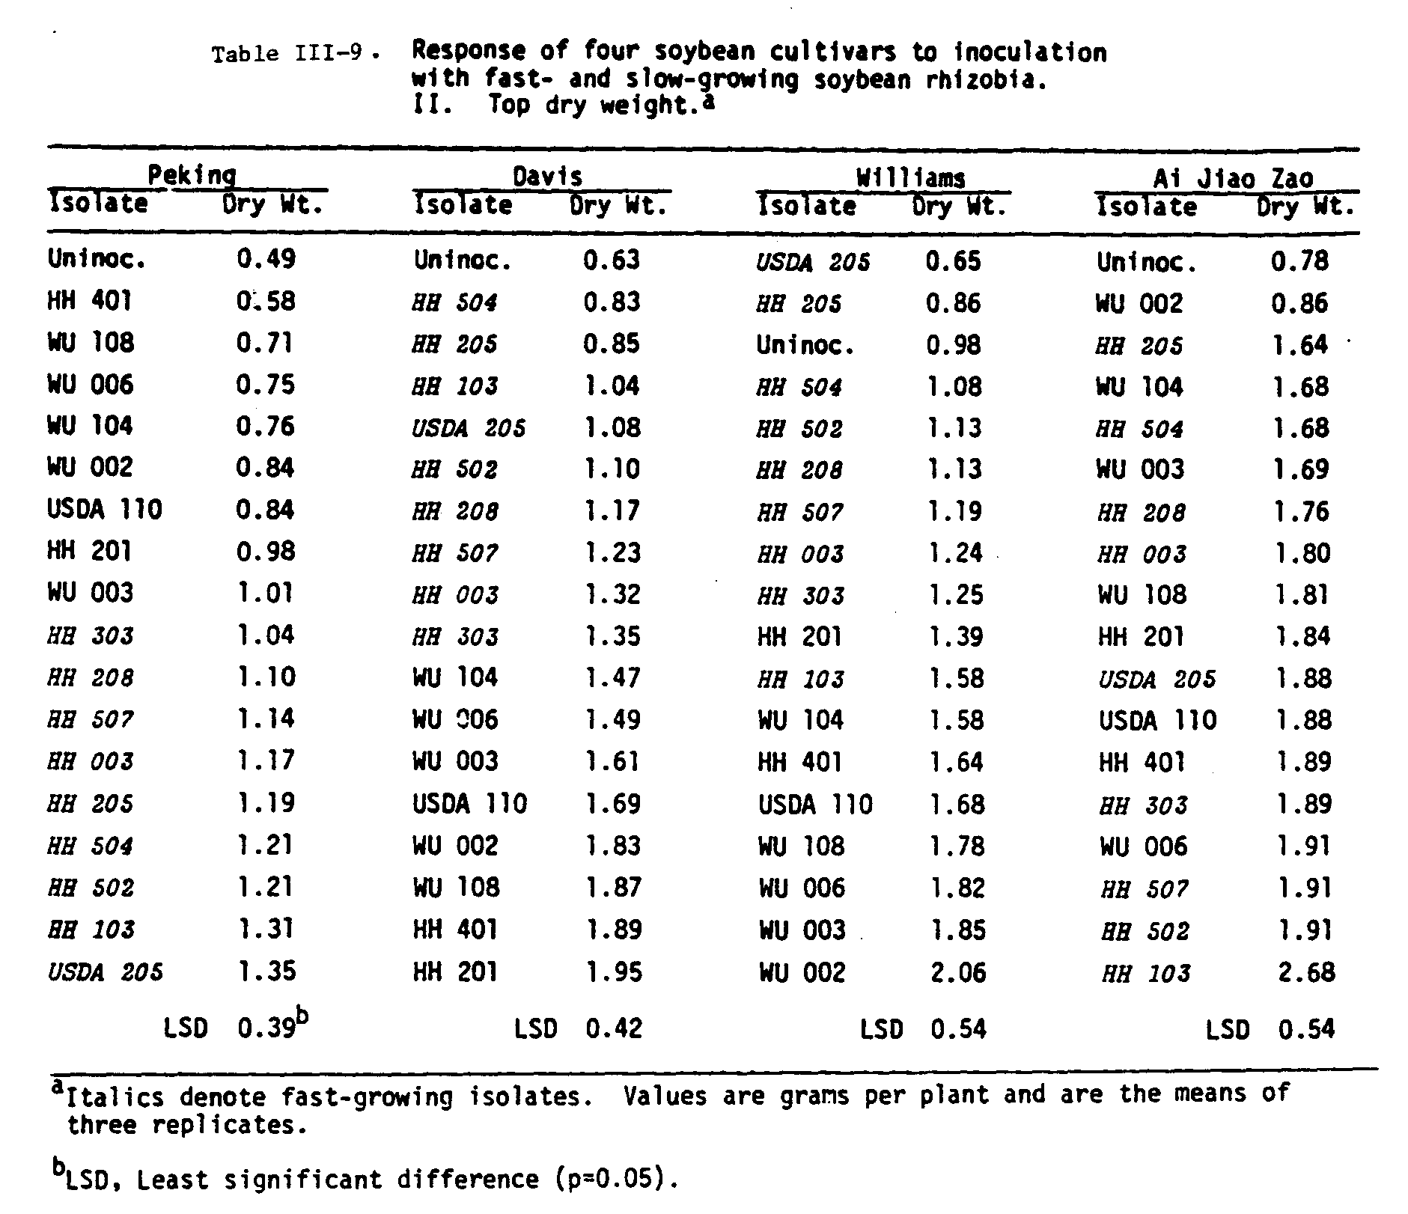
1982) were isolated from soybean root nodules collected in four east-central provinces. In this study, fast-growers were isolated from a soil in Hubei province in central China where agriculture is primarily devoted to paddy rice with only scattered acreage of soybeans. The implication is that fast-growing soybean rhizobia may be a common component of the natural microflora in China. In contrast to the soybean soil, the composition of indigenous slow-growing soybean rhizobia in the rice soil was homogeneous. Despite the fact that soybeans had never been cultivated in this soil, soybean rhizobia were present, albeit in low numbers (data not shown). In China, it is common for soils to contain soybean rhizobia irrespective of their cropping histories, presenting a particular challenge when introducing highly effective inoculum strains on soybeans. In the United States, in soils where soybeans have been grown previously, establishment of selected inoculum strains of rhizobia has been largely unsuccessful due to competition from indigenous rhizobia (Ham et al., 1971; Vest et al., 1973; Kvien et al., 1981).
It is interesting that the bulk of the slow growers in the rice soil cross-reacted with FAs prepared against strains USDAl10 and CB1809, two highly effective and widely used inoculum strains (Keyser, personal communication). In addition, two of the more extreme rhizobia-cultivar interactions reported in the literature were encountered in our limited sampling: the bacteria-induced chlorosis (Erdman et al., 1957) induced by the slow-growing isolate HH401 on the cultivar Peking, and the ineffective reponse between Ai Jiao Zao and WU002 which is similiar to the ineffective response between strains in the 122 serogroup (eg. CB1809) and the cultivar Hardee (Caldwell, 1966). As noted above, WU002 also falls within the 122 serogroup.
The fast-growing soybean rhizobia previously reported could be separated into at least three distinct serogroups based on immunodifusion reactions with the somatic antisera produced against USDA192, 194, and 205 (M. J. Sadowsky, Ph.D. thesis, University of Hawaii, 1983). Several of the fast-growing isolates in this study are distinct from the previously reported fast-growers and did not fall into any one of the three serogroups. In addition, the host range for effective nodulation of these isolates was different from that reported earlier. Keyser et al. (1982) reported the fast growers nodulated M. atropurpureum, S. cannabina, and Glycine max cv. Williams ineffectively, whereas some of the isolates in this study formed effective symbioses on these hosts. The highly significant cultivar-strain interactions, not found with the slow growers to the same extent, deserve further investigation which could lead to identification of the genes reponsible for host-strain specificity.
To our knowledge, this is the first report illustrating the predominance of fast-growing soybean rhizobia under natural conditions. This belies the conclusion that fast-growing soybean rhizobia represent an anamolous situation of little practical significance. Since the results presented in this study emanate from samples taken from one soybean field in China, we must excercise restraint in making generalizations. More collections from similar fields in China are required to establish a better understanding of indigenous soybean rhizobia populations. However, we did find: 1) in a soil that has been under soybean cultivation for decades, fast-growing rhizobia were predominant; 2) this population had diverse microbiological and symbiotic characterisitics; 3) there were highly significant cultivarstrain interactions; and 4) in a rice soil that had no prior history of soybean cultivation the predominant soybean rhizobia were effective, slow-growing strains.

Acknowledgments

We thank Central China Agriculture College for their assistance in arranging field visits, and Prof. H.K. Chen for his interest and encouragement.
This work was supported in part by contract AID/ta-C-1207 (NifTAL Project) and by a fellowship from the National Academy of Science’s Committee on Scholarly Communication with the People’s Republic of China.
Literature Cited

Belser, L.W., and E.L. Schmidt. 1978. Diversity in the ammonia-oxidizing nitrifier populations of a soil. Appl. Environ. Microbiol. 36:584-588.

Bishop, P.E., J.G. Guevara, J.A. Engelke, and H.J. Evans. 1976. Relation between glutamine-synthetase and nitrogenase activities in the symbiotic association between Rhizobium japonicum and Glycine max. Plant Physiol. 57:542-546.

Bohlool, B.B., and E.L. Schmidt. 1968. Nonspecific staining: its control in immunofluorescence examination of soil. Science 162:1012-1014.

Caldwell, B.E. 1966. Inheritance of a strain-specific ineffective nodulation in soybeans. Crop Science 6:427-428.

Erdman, L.W., H.W. Johnson, and F. Clark. 1957. Varietal responses of soybeans to a bacterial-induced chlorosis. Agron. J. 49:267-271.

Gamborg, O.L. 1975. Callus and cell cultures, p.l-9. In O.L. Gamborg and L.R. Wetter (eds.), Plant tissue culture methods. National Research Council of Canada, Saskatoon, Saskatchewan.

Ham, G.E., V.B. Cardwell, and H.W. Johnson. 1971. Evaluation of Rhizobium japonicum inoculants in soils containing naturalized populations of rhizobia. Agron. J. 63:301-303.

Hattori, J., and D.A. Johnson. 1984. Fast-growing Rhizobium japonicum that effectively nodulates several commercial Glycine max L. Merrill cultivars. Appl. Environ. Microbiol. 48:234-235.

Hoagland, D.R., and D.I. Arrnon. 1938. The water culture method for growing plants without soil. Calif. Agric. Exp. Stn. Circ. 347.

Hymowitz, T., and C.A. Newell. 1981. Taxonomy of the genus Glycine, domestication, and uses of soybeans. Econ. Botany 35:272-288.

Jordan, D.C. 1984. Family III. Rhizobiaceae, p.234-256. In N.R. Krieg and J.G. Holt (eds.), Bergey’s Manual of Systematic Bacteriology, Vol. 1. The Williams and Wilkins Co., Baltimore.

Jordan, D.C., and O.N. Allen. 1974. Genus II. Rhizobium, p262-264. In R.E. Buchanan and N.E. Gibbons (eds.), Bergey’s Manual of Determinative Bacteriology, 8th ed. The Williams and Wilkins Co., Baltimore.

Josey, D.P., J.L. Beynon, A.W.B. Johnston, and J.E. Beringer. 1979. Strain identification in Rhizobium japonicum using intrinsic antibiotic resistence. J. Appl. Bacteriol. 46:343-350.

Keyser, H.H., B.B. Bohlool, T.S. Hu, and D.F. Weber. 1982. Fastgrowing rhizobia isolated from root nodules of soybean. Science 215:1631-1632.
Keyser, H.H., M. J. Sadowsky, and B.B. Bohlool. 1985. Fast-growing soybean rhizobia. In R. Shibles (ed.), World soybean research conference III: proceedings, Westview Press, Boulder.

Kingsley, M.T., and B.B. Bohlool. 1983. Characterization of Rhizobium sp. (Cicer arietinum L.) by immunofluorescence, immunodiffusion, and intrinsic antibiotic resistance. Can. J. Microbiol. 29:518-526.

Kvien, C.S., G.E. Ham, and J.W. Lambert. 1981. Recovery of introduced Rhizobium japonicum strains by soybean genotypes. Agron. J. 73:900-905.

May, S.N., and B.B. Bohlool. 1983. Competition among Rhizobium leguminosarum strains for nodulation of lentils (Lens esculenta). Appl. Environ. Microbiol. 44:960-965.

Sadowsky, M.J., H.H. Keyser, and B.B. Bohlool. 1983. Biochemical characterization of fast- and slow-growing rhizobia that nodulate soybeans. Int. J. Syst. Bacteriol. 33:716-722.

Schmidt, E.L., R.O. Bankole, and B.B. Bohlool. 1968. Fluorescent antibody approach to the study of rhizobia in soil. J. Bacteriol. 95:1987-1992.

Soil Conservation Service. 1984. In Soil survey laboratory methods and procedures for collecting soil samples. U.S. Department of Agriculture, Washington, D.C.

Stowers, M.D., and A.R.J. Eaglesham. 1984. Physiological and symbiotic characteristics of fast-growing Rhizobium japonicum. Plant and Soil 77:3-14.

Van Rensburg, H.J., B.W. Strijdom, and C.J. Otto. 1983. Effective nodulation of soybeans by fast-growing strains of Rhizobium japonicum. South African J. of Sci. 79:251-259.

Vest, G., D.F. Weber, and C. Sloger. 1973. Nodulation and nitrogen fixation, p.353-390. In B.E. Caldwell (ed.), Soybeans: improvement, production, and uses. Monograph 16. American Society for Agronomy, Madison, Wis.

Vincent, J.M. 1970. A manual for the practical study of root-nodule bacteria. IBP handbook 15. Blackwell Scientific Publications, Oxford.

Vincent, J.M. 1974. Root-nodule symbiosis with Rhizobium, p.265-347. In A. Quispel (ed.), Biology of nitrogen fixation. North-Holland Publishing Co., Amsterdam.
CHAPTER IV
THE COMPETITIVE ADVANTAGE OF INDIGENOUS FAST-GROWING SOYBEAN RHIZOBIA

Abstract

Fast-growing soybean rhizobia occur naturally in soils in China yet their influence in competition with slow-growing inoculum strains is unknown. A glasshouse study was designed to analyze competition between effective, naturally occurring fast-and slow-growing rhizobia for nodulation on the roots of soybeans (G. max L. Merrill). Two soybean cultivars, Ai Jiao Zao and Williams, were grown in three soils: one with an indigenous population of fast-growing soybean rhizobia, one with an indigenous population of slow-growing soybean rhizobia, and one devoid of soybean rhizobia. Fast-and slow-growing Rhizobium japonicum were added to the soils in low and high numbers either as single strain or multi-strain inocula. The fast-growing rhizobia were highly competitive on both cultivars in the soil where they occurred naturally even when slow-growing inoculum strains were added to the soil in high numbers. When a high number of one fast-growing strain was added to the soil with indigenous slow-growers, it formed 86% of the nodules on Ai Jiao Zao and 41% on Williams. However, when slow-growing strains were included with the fast-growing strain in a multi-strain inoculum, the fast-growing strain was a poor competitor in the rhizobia-free soil as well as in the soil where the slow-growers were indigenous.

Introduction

An important objective in legume inoculation is to establish highly effective inoculum strains in the rhizosphere so they can compete successfully for nodule sites against indigenous soil rhizobia. With respect to soybeans in particular, inoculum strains superior in nitrogen fixation have frequently failed to compete successfully with indigenous rhizobia in soils where soybeans have been cultivated (Johnson et al., 1965; Ham et al., 1971a; Boonkerd et al., 1978). Several studies have reported increased recovery of inoculum strains in soybean nodules by applying the inoculum strains in high numbers relative to the indigenous rhizobia (Bohlool and Schmidt, 1973; Kapusta and Rouwenhorst, 1973; Weaver and Frederick, 1974). However, the high numbers that are needed to overcome indigenous rhizobia are in many cases not practical for soybean cultivation.
In much of the soybean growing area in the north central United States, an area encompassing many soil types, indigenous strains of Rhizobium japonicum serogroup 123 dominate nodulation of soybeans (Damirgi et al., 1967; Ham et al., 1971b). Although several factors have been examined to account for the success of serogroup 123 (Ham, 1980), strain characteristics that confer competitive advantage to 123 remain unknown. The competitive success of 123 was found not to be related to an ability to outgrow other indigenous R. japonicum in the host rhizosphere (Moawad et al., 1984). Also, when competition studies were carried out in sterile vermiculite and in soils devoid of naturalized R. japonicum, strain 123 was found to be a poor competitor (Kosslak and Bohlool, 1985).
A similar situation may exist in China with fast-growing soybean rhizobia. Recently, Keyser et al. (1982) reported for the first time fast-growing strains of rhizobia isolated from soybean root nodules collected in four east-central provinces in the People’s Republic of China. Studies have shown these fast-growing rhizobia to be distinct in their microbiological properties from the “typical” slow-growing types (Sadowsky et al., 1983; Stowers and Eaglesham, 1984). In the previous chapter it was shown that although effective slow-growing soybean rhizobia were present in an uninoculated soybean field in relatively high numbers, the majority of nodules were formed by fast-growing rhizobia. This evidence suggests fast-growing soybean rhizobia may be a common component of the natural microflora in China, the center of origin and genetic diversity of soybeans and presumably of its rhizobia.
Studies designed to determine inter-strain competition of fast-and slow-growing rhizobia are few. Franco and Vincent (1976) studied the competition between a fast-growing isolate from Leuceana (ineffective on siratro) and an effective slow-grower. They found nodulation on siratro was almost entirely due to the effective slow-grower unless the ratio of slow-to fast-growers in the inoculum was extremely favorable to the fast-growing strain. Zablotowicz and Focht (1981) compared a poorly effective fast-grower and effective slow-growers isolated from cowpeas and found the fast-grower produced 95% of the nodules when challenged with one slow-grower, but only 6% when challenged with another slow-grower. Trinick et al. (1983) studied effective fast-and slow-growing strains on cowpea and found at lower temperatures the fast-growing strain was a superior competitor for nodule sites, whereas at higher temperatures the slow-growing rhizobia were the better competitors. It is important to note, however, that the fast-growers were not the host-preferred microsymbiont under natural conditions in any of these studies. The behavior of fast-growing rhizobia as indigenous soil bacteria and their influence in competition between indigenous bacteria and inoculum strains has not heretofore been addressed.
The present study analyzes the competitive ability of effective fast-and slow-growing strains of soybean rhizobia for nodulation of the roots of soybeans in three soils: one with an indigenous population of fast-growers, one with an indigenous population of slow-growers, and one devoid of Rhizobium japonicum.

Materials and Methods

Soils and soybean cultivars. The chemical properties and cropping histories of the two Chinese soils used in this study were described in Chapter III. The Honghu soil had been under soybean cultivation without inoculation for decades and had an indigenous population of fast-growing soybean rhizobia. The Wuhan soil had been under continuous paddy rice cultivation with no record of prior soybean cultivation and had an indigenous population of slow-growing soybean rhizobia. The third soil, a Waimea very fine sandy loam (Typic Eutrandept, medial, isothermic) was collected on the island of Hawaii and had no indigenous population of soybean rhizobia. The pH of the Waimea soil determined in a 1:1 suspension of soil to water was 6.3; and 5.8 in a 1:1 suspension of soil to 1 N KCl. Samples were measured with an Orion Research (model 501) pH meter and a glass combination electrode after 1 h equilibration. Two soybean (Glycine max L. Merrill) cultivars were used in this study: Ai Jiao Zao, a genetically improved, yellow-seeded cultivar released by the Oils and Root Crop Institute in Wuhan for use in Hubei province; and Williams, a widely planted commercial cultivar in North America.
R. japonicum strains. The fast-growing Rhizobium strain used in this study was HH003, isolated from the Honghu soil and effective on both cultivars. The slow-growing strains, WU002 and WU006, were isolated from the Wuhan soil. WU006 was effective on both cultivars whereas WU002 was effective on Williams but ineffective on Ai Jiao Zao. The procedures used to isolate the strains were described in Chapter III. Rhizobium cultures were grown and maintained in yeast extract mannitol (YEM) medium (Vincent, 1970); the YEM agar slants used for the maintenance of fast-growing isolates contained 0.05% CaCO₃.
Soil and inoculum preparation. Since the soil had been in cold storage, the indigenous soybean population in the two Chinese soils was stimulated by planting a dense population of soybean seeds in the soil. The seedlings were removed after ten days. All three soils were sieved (2 mm) and the number of rhizobia in the soils was determined by plant infection using a most probable number (MPN) technique (Vincent, 1970). Ten grams of soil were added to 95 ml of YEM salts, placed on a wrist action shaker for 20 min, and ten-fold serial dilutions were made in YEM salts. One ml of each ten-fold dilution was inoculated onto 4 d old Glycine soja seedlings growing in test tubes with Hoagland’s nitrogenfree plant nutrient agar (Hoagland and Arron, 1938) in a Sherer model CEL4-7 controlled-environment growth chamber at 27⁰C. The plants were examined after four weeks for the presence of nodules.
Rhizobium cultures for inoculum preparations were grown in yeast extract mannitol (YEM) broth until early stationary phase. The cultures were centrifuged (6,000 X g) to remove excess media, and resuspended in 0.85% saline. For each culture, a cell count was made using a Petroff-Hauser chamber and the cultures were adjusted to the same concentration with the addition of 0.85% saline. In addition, viable counts from each adjusted culture were determined by the drop plate method (Miles and Misra, 1938).
Glasshouse experiment. Due to scarcity of soil materials from China, different treatments had to be designed for each soil. Inocula were added to the soils at two levels and were mixed thoroughly into the soil to simulate the placement of indigenous rhizobia. Thorough mixing of the inoculum and the soil was accomplished by first incorporating the inoculum strains into peat and then mixing the peat-rhizobia mixture into the soil to give the desired final concentration. Seeds were surface sterilized for 20 min in 4% calcium hypochlorite, washed extensively in sterile water, and three seeds of each cultivar were sown into 16 oz plastic cups containing 350 g soil. Inoculum was also introduced into the soil with peat pelleted seeds which were prepared using the procedures outlined by Vincent (1970). Each seed harbored approximately 1x10⁵ cells of the desired rhizobial mixture as determined by viable count on YEM agar. Seedlings were subsequently thinned leaving one seedling of each cultivar per cup. After thinning, the top of the soil was covered with a 3 cm layer of fine gravel. Soils were maintained at 60% water holding capacity throughout the experiment. A plastic straw (6 mm dia) extending to the bottom of the cup facilitated watering with 1/4 strength Hoagland’s nitrogen-free solution. There were three replicates for each treatment arranged in a randomized complete block design. Plants were harvested after 4 weeks, and all nodules were collected and serotyped by immunofluorescence. Data were analyzed by ANOVA and Duncan’s multiple range tests. Data given in percentages were converted to ranks before being analyzed.
Immunofluorescence. Preparation of fluorescent antibodies (FAs and immunofluorescent staining of nodules are described elsewhere (Schmidt et al., 1968). Strain WU002 was serologically identical to USDA136b (CB1809) and identified using FA USDA136b. Likewise, WU006 was identified using FA USDAl10, and HH003 was identified using FA USDA205. Smears from nodules were treated with gelatin-rhodamine isothiocyanate conjugate to suppress nonspecific staining (Bohlool and Schmidt, 1968). Microscopy was done as described previously (May and Bohlool, 1983); transmitted light microscopy , i.e., phase contrast with an achromaticaplanatic DIC condenser VZ, was used to observe dual infection.

Results

In the soybean soil from Honghu, with an indigenous population of fast-growing rhizobia, the slow-growing inoculum strains were unable to displace completely the indigenous fast-growing rhizobia and occupy a majority of nodules in any of the treatments (Table IV-1). The slow-growers were poor competitors on Ai Jiao Zao failing to form a significant proportion of nodules even when they were added to the soil in high numbers. On Williams, when slow-growing strains were added to the soil in high numbers, the more canpetitve slow-grower, WU006, was able to occupy 43% of the nodules versus 59% for the indigenous fast-growing rhizobia; and this was reduced to 17% for WU006 when an indigenous fast-grower was included in the inoculum.
In the other Chinese soil, the rice soil from Wuhan with an indigenous population of slow-growing rhizobia, the fast-growing inoculum strain HH003 was poorly competitive and unable to displace the indigenous rhizobia when mixed into the soil in low numbers (Table IV-2). When the fast-grower was introduced into the soil in a peat pelleted seed inoculum, it was able to form approximately the same proportion of nodules on Ai Jiao Zao as the indigenous slow-growing strains. And when HH003 alone was added in high numbers, it occupied 86% of the nodules on Ai Jiao Zao, and 41% on Williams. However, when the fast-grower was added in high numbers together with two indigenous slow-growing strains, the fast-grower was only able to occupy only 17% and 8% of the nodules on Ai Jiao Zao and Williams respectively.
In the R. japonicum-free Waimea soil, the slow-growing strains were more competitive than the fast-growing strain HH003 (Table IV-3). Strain VJJ006 was the most competitive strain occupying approximately 80% of the nodules on both cultivars; strain HH003 occupied the remaining 20% of the nodules on Ai Jiao Zao while the remaining 20% on Williams were occupied by WU002.

Discussion

Prior to the report of fast-growing rhizobia isolated from soybean root nodules collected in China (Keyser et al., 1982), soybeans were considered to be nodulated only by slow-growing rhizobia. At present, China is the only country where fast-growing rhizobia are known to occur naturally. The results from Chapter III have demonstrated that under certain conditions fast-growing rhizobia are the predominant soybean microsymbiont.
Competition between the fast-and slow-growing strains was influenced by the cultivar, the method of inoculation, and the indigenous population. In this study, the indigenous fast-growing rhizobia were highly competitive and formed most of the nodules on both cultivars grown in the Honghu soybean soil. The relatively high indigenous population of fast-growers in the soil may have contributed to the poor competitiveness of the slow-growing inoculum strains. Kosslak and Bohlool (1985) looked at the competitive ability of the slow-growing strain 123, the most competitive of the native strains in soils of the north central United States (Ham, 1980). Although highly competitive as a native strain, 123 was a poor competitor in sterile vermiculite, vermiculite amended with its native soil, and in a R. japonicum-free soil. Similarly, in this study the fast-growing strain HH003 was poorly competitive in the rhizobia-free Waimea soil. The pattern of competition in the rhizobia-free Waimea soil was clearly in favor of the slow-grower WU006.
Trinick et al. (1983) studied competition between a fast-grower and a slow-grower and reported that when the total numbers in a mixed inoculum were low, the fast-growing strain was a better competitor; on the other hand, when the numbers in the inoculum were high, the slow-growing strain was the better strain and formed more nodules. In the R. japonicum-free Waimea soil, mixed inocula were added to the soil at two levels, and the total number of cells in the inoculum had no influence on the competitive ability of the inoculum strains.
When the fast-grower, HH003, was tested in a single-strain inoculum mixed into the Wuhan rice soil with an indigenous population of effective slow-growers, its competitive success was influenced by the soybean cultivar and inoculation rate. Weaver and Frederick (1974) predicted that for soils in the upper midwest in the soybean growing region of the U.S., if the inoculum rhizobia are to form 50% or more of the nodules then an inoculation
rate of at least 1,000 times the soil rhizobia population must be used. In the Wuhan rice soil, HH003 occupied 86% of the nodules on Ai Jiao Zao, but only 41% of the nodules on Williams even though the ratio of inoculum to indigenous rhizobia was 31,000:1. When HH003 was mixed into the soil in lower numbers, or mixed into the soil together with two indigenous slow-growing strains, its competitive success was greatly reduced.
In general, HH003 was more competitive on Ai Jiao Zao than on Williams. This is consistent with the observation that Williams had a greater affinity for slow-growing rhizobia whereas Ai Jiao Zao had a greater affinity for fast-growing rhizobia. The relative affinity was based on the nitrogen-fixing effectiveness of the symbioses formed between the two cultivars and the various isolates from the soybean and rice soil (see Chapter III).
The competitive ability of the slow-growers was also influenced by the soybean cultivars. This was due, in large part, to the ineffective symbiotic association between Ai Jiao Zao and WU002. MJ002 was a poor competitor on Ai Jiao Zao and able to form a significant number of nodules on this cultivar only when it was an indigenous strain. Diatloff and Brockwell (1976) observed a similar pattern of poor competitiveness with an ineffective cultivar (Hardee)-strain (CB1809) association and high competitiveness with an effective cultivar (Hampton)-strain (CB1809) association. Furthermore, they reported that when an ineffective strain was included in the inoculum, nodule formation by the effective strains was suppressed. This suppression effect did not occur in this study.
Although the number of rhizobia differed greatly between inoculum treatments, there was no significant effect on the number of nodules formed. Between 0-5% of the nodules were doubly infected by either two slow-growers or by a fast-and a slow-grower. Dual occupancy of nodules by fast-and slow-growing rhizobia has been reported before (Trinick et al., 1983).
Studies have shown the fast-growing soybean rhizobia are distinct in their microbiological properties from the “typical” slow-growing types (Sadowsky et al., 1983; Stowers and Eaglesham, 1984). The results of this study demonstrate that the fast-growers are highly competitive in their native soils, and under certain conditions, as inoculum strains. More studies in soils from China are needed to determine the extent of the occurrence of fast-growing soybean rhizobia, their competitiveness under natural conditions, and their symbiotic effectiveness on genetically diverse cultivars of soybeans.
Literature Cited

Bohlool, B.B., and E.L. Schmidt. 1968. Nonspecific staining: its control in immunofluorescence examination of soil. Science 162: 1012-1014.

Bohlool, B.B., and E.L. Schmidt. 1973. Persistence and competition aspects of Rhizobium japonicum observed in soil by immunofluorescence microscopy. Soil Sci. Soc. Am. J. 73:561-564.

Boonkerd, N., D.F. Weber, and D.F. Bezdicek. 1978. Influence of Rhizobium japonicum strains and inoculation methods on soybean grown in rhizobia-populated soils. Agron. J. 70:547-549.

Damirgi, S.M., L.R. Frederick, and I.C. Anderson. 1967. Serogroups of Rhizobium japonicum in soybean nodules as affected by soil types. Agron. J. 59:10-12.

Diatloff, A., and J. Brockwell. 1976. Symbiotic properties of Rhizobium japonicum and competitive success in nodulation of two Glycine max cultivars by effective and ineffective strains. Aust. J. Exp. Agric. Anim. Hus. 16:514-521.

Franco, A.A., and J.M. Vincent. 1976. Competition amongst rhizobial strains for the colonization and nodulation of two tropical legumes. Plant and Soil 45:27-48.

Ham, G.E. 1980. Inoculation of legumes with Rhizobium in competition with naturalized strains. p.131-138. In W.E. Newton and W.H. Orme-Johnson (ed.), Nitrogen Fixation, vol. II. University Park Press, Baltimore.

Ham, G.E., V.B. Cardwell, and H.W. Johnson. 1971a. Evaluation of Rhizobium japonicum inoculants in soils containing naturalized populations of rhizobia. Agron. J. 63:301-303.

Ham, G.E., L.R. Frederick, and I.C. Anderson. 1971b. Serogroups of Rhizobium japonicum in soybean nodules sampled in Iowa. Agron. J. 63:6972.

Hoagland, D.R., and D.I. Arron. 1938. The water culture method for growing plants without soil. Calif. Agric. Exp. Stn. Circ. 347.

Johnson, H.W., U.M. Means, and C.R. Weber. 1965. Competition for nodule sites between strains of Rhizobium japonicum applied as inoculum and strains in the soil. Agron. J. 57:179-185.

Kapusta, G., and D.L. Rouwenhorst. 1973. Influence of inoculum size on Rhizobium japonicum serogroup distribution frequency in soybean nodules. Agron. J. 65:956-919.

Keyser, H.H., B.B. Bohlool, T.S. Hu, and D.F. Weber. 1982. Fast-growing rhizobia isolated from nodules of soybean. Science 215:1631-1632.
Kosslak, R.M., and B.B. Bohlool. 1985. Influence of environmental factors on interstrain competition in Rhizobium japonicum. Appl. Environ. Microbiol. 49:000-000.

May, S.N., and B.B. Bohlool. 1983. Competition among Rhizobium leguminosarum strains for nodulation of lentils (Lens esculenta). Appl. Environ. Microbiol. 45:960-965.

Miles, A.A., and S.S. Misra. 1938. The estimation of the bacteriocidal power of blood. J. Hyg. Camb. 38:732-749.

Moawad, H.A., W.R. Ellis, and E.L. Schmidt. 1984. Rhizosphere response as a factor in competition among three serogroups of indigenous Rhizobium japonicum for nodulation of field-grown soybeans. Appl. Environ. Microbiol. 47:607-612.

Sadowsky, MO., H.H. Keyser, and B.B. Bohlool. 1983. Biochemical characterization of fast-and slow-growing rhizobia that nodulate soybeans. Int. J. Syst. Bacteriol. 33:716-722.

Schmidt, E.L., R.O. Bankole, and B.B. Bohlool. 1968. Fluorescent antibody approach to the study of rhizobia in soil. J. Bacteriol. 95:1987-1992.

Stowers, M.D., and A.R.J. Eaglesham. 1984. Physiological and symbiotic characteristics of fast-growing Rhizobium japonicum. Plant and Soil 77:3-14.

Trinick, M.J., R.L. Rhodes, and J.H. Galbraith. 1983. Competition between fast-and slow-growing tropical legume rhizobia for nodulation of Vigna unguiculata. Plant and Soil 73:105-115.

Vincent, J.M. 1970. A manual for the practical study of root-nodule bacteria. I.B.P. handbook 15. Blackwell Scientific Publications, Oxford.

Weaver, R.W., and L.R. Frederick. 1974. Effect of inoculum rate on competitive nodulation of Glycine max L. Merrill. II. Field studies. Agron. J. 66:233-236.

Zablotowicz, R.M., and D.D. Focht. 1981. Physiological characteristics of cowpea rhizobia: evaluation of symbiotic efficiency in Vigna unguiculata. Appl. Environ. Microbiol. 41:679-685.
CHAPTER V
BACTERIOPHAGES FOR FAST-GROWING SOYBEAN
RHIZOBIA ISOLATED FROM A CHINESE SOIL

Abstract

A new group of fast-growing rhizobia that nodulate soybeans has been reported recently. In Chpater III, it was shown that all of the nodules from soybeans grown in a soil from central China that had been under soybean cultivation contained fast-growing, acid-producing rhizobia. In contrast, only slow-growing R. japonicum were obtained from a rice soil from the same province in China. In this chapter, evidence is presented showing that rhizobiophages specific for the fast-growing soybean rhizobia were present in the soybean soil. Phages were recovered from the soybean soil directly from ultracentrifuged soil suspensions and after enrichment with the indigenous host rhizobia. From the rice soil, rhizobiophage were not recovered despite enrichment with indigenous slow-growing isolates and with a fast-growing isolate from the soybean soil. The phages exhibited a high degree of host specificity and were lytic on fast-growing soybean rhizobia only. At least 3 distinct plaque types were observed. Electron microscopy revealed diverse morphology among this group of phages. Phages for slow-growing R. japonicum were not recovered from either soil. The indigenous fast-growing rhizobia isolates from the soybean soil were grouped into seven phage-sensitivity groups based on a phage-typing scheme.

Introduction

Rhizobium sp. are susceptible to attack and lysis by bacteriophages. Bacteriophages and their lytic action have been described for all the main groups of rhizobia (Vincent, 1977). Most of the reports have concerned phages for the fast-growing rhizobia types, while less attention has been given the phages for the slow-growers.
Bacteriophages specific for rhizobia are commonly found in soils where the legume hosts for the rhizobia are grown and only occasionally in soils were the host legume has not been cultivated (Katznelson and Wilson, 1941; Kleczkowska, 1957; Kowalski et al., 1974). The influence of rhizobiophages on the culture of legumes and rhizobial ecology has been the subject of controversy. Early work ascribed a role for bacteriophages in the decline of productivity of soils where lucerne had been cultivated (Demolon and Dunez, 1935;). Kleczkowska (1950) indicated that phage-resistant mutants of Rhizobium trifolii appearing in the presence of phage produced less effective nodules than the parent form of the bacteria. Evans et al. (1979) demonstrated the ability of bacteriophage to reduce the population of susceptible strains in the root zone of Trifolium growing in seedling agar. Schwinghamer and Brockwell (1978) reported a competitive advantage for phage-producing strains of R. trifolii in broth and peat cultures. Several investigators have reported the production by Rhizobium sp. of bacteriocins that resemble phage-like structures (Lotz and Mayer, 1972; Schwinghamer et al., 1973; Joseph et al., 1985) although the ecological significance for the producer strain has not been demonstrated. Other studies have concluded that bacteriophages had no effect on nodulation, nitrogen fixation, and normal growth of legumes (Laird, 1932; Almon and Wilson, 1933; Bruch and Allen, 1955; Kleczkowska, 1945).
Until the report of Keyser et al. (1982) soybeans were considered to be commonly nodulated by slow-growing rhizobia only. It is now accepted that soybeans are nodulated by both fast-and slow-growing rhizobia (Keyser et al., 1985). At present, fast-growing soybean rhizobia are known to occur naturally only in soils in China. Heretofore, there have been no data on the occurrence of phages for fast-growing soybean rhizobia. This chapter is the first report of the isolation of phages for fast-growing soybean rhizobia from a soil from China.

Materials and Methods

Soils and Rhizobium strains. Two soils from China were used to isolate phages. The chemical properties and cropping histories of the soils were described in Chapter III. The Honghu soybean soil had been under soybean cultivation for decades whereas the Wuhan rice soil had been under continuous flooded rice cultivation with no prior history of soybean cultivation. The Honghu soil had an indigenous population of both fast-and slow-growing soybean rhizobia, whereas the Wuhan rice soil had an indigenous population of only slow-growing soybean rhizobia. The Rhizobium strains used to isolate phages from these soils were indigenous bacteria, and the isolation procedures were described in Chpater III. In addition, one fast-growing Rhizobium japonicum strain, USDA205, one of the original fast-growing Rhizobium japonicum strains reported by Keyser et al. (1982) and not indigenous to either soil, was used to isolate phages. The strains were maintained on yeast extract mannitol (YEM) (Vincent, 1970) agar slants; the agar slants used for the maintenance of fast-growing isolates contained 0.05% CaCO₃. Other rhizobia tested for phage host range are listed in Table V-2.
Phage isolation and purification. Methods of isolation, purification, and propagation were essentially as described by Adams (1959). Two procedures, with and without prior enrichment, were used to isolate phages. The host rhizobia strains indigenous in the two soils were chosen on the basis of being in different intrinsic antibiotic resistence (IAR) groups (see Chapter III). For the enrichment procedure with the fast-growers, 5 g of soil was added to 50 ml of an exponentially growing Rhizobium strain in mannitol nitrate (MN) defined medium (Vincent, 1970). The cultures were incubated for 36 h on a rotary shaker, and following a mild centrifugation (4,000 x g) to remove most of the soil and bacterial cells, the supernatation was added to another exponentially growing culture of the enriching Rhizobium for 18 h. This was repeated twice so that the phages were passed through four enrichment treatments of the Rhizobium strain. After the final enrichment, the supernatation was filtered on membrane filters (Nuclepore .40 um pore size). The enrichment procedure with the slowgrowers was similar to the procedure for the fast-growers except the length of the first enrichment period was 48 h, followed by three 36 h periods.
To isolate phages from soil without prior enrichment, 10 g of soil was placed in 95 ml of phage diluting broth (Vincent, 1970) and placed on a wrist action shaker for 15 min. The soil suspension was centrifuged (4000 x g, 20 min) to remove bulk soil particles, followed by an ultracentrifugation (30,000 rpm, 30 h) after which the pellet was resuspended in phage diluting broth and filtered on membrane filters as above.
Suspensions were assayed for plaque formation on the enriching strain using the standard agar overlay method (Adams, 1959) which was performed as follows: MN medium with 1.0% agar (Sigma) was used as the basal agar layer, and MN medium with 0.42% agar (Sigma) was used as the top layer. Each phage was purified by three successive single-plaque isolations on its original host. Once purified, high titer phage stock solutions were prepared by passing the phage through three exponentially growing cultures of the host rhizobia similar to the methods described above. Phage stock solutions were stored at 4⁰C.
Electron microscopy. A drop of phage suspension was applied to a one hole grid with a Formvar support and stained with 2% uranyl acetate. The grid was examined using a Zeiss 10/A electron microscope operated at 80 kV.
Host sensitivity and phage typing. Double layer agar plates were prepared as above. 200 ul of a turbid culture of the host rhizobia was added to the molten (48⁰C) soft agar layer and spread onto the basal agar layer. 250 ul of a 10⁻¹ dilution of the high titer phage stock solutions were added to the wells of a sterile Costar 96-well tissue culture cluster. A multiple inoculator was flame-sterilized with 95% EtOH and, after cooling, set into the wells and then allowed to set on the upper agar layer after it had solidified. Phage suspensions were added to each plate in duplicate, and each host was replica-plated; thus each phage-host combination was replicated four times. Plates were examined after 48 h incubation at 28⁰C. Control plates consisted of the host-rhizobia added to the molten soft agar layer and spread onto the basal agar layer. The multiple inoculator was flame-sterilized and, after cooling, set on the upper layer. No phages were added to the control plates. Lysogens were detected when plaques appeared on the control plates and were not included in the phage-typing scheme.

Results

Rhizobiophages for the native fast-growing rhizobia in the Honghu soybean soil were obtained with or without prior enrichment with the host rhizobia (Table V-1). Six fast-growing strains native to the Honghu soil were selected and phages were obtained for each host strain. When two slow-growing strains native to the Honghu soil were used as host bacteria, phages were not detected in the Honghu soil even, after enrichment with these indigenous slow-growing hosts. Similarly, when the non-native fast-growing R. japonicum strain USDA205 was used enrich for phages in the Honghu soil, no phages were detected. In the Wuhan rice soil, rhizobiophages were not isolated despite attempts to enrich for them with native slow-growing strains, non-indigenous fast-and slow-growing strains from the Honghu soil, and USDA205.
Differences in phage morphology were observed by electron microscopy. Four distinct phage morphologies were observed. Phage HH204 was characterized by an icosahedral head 39 nm in diameter and a flexuous, non-contractile tail
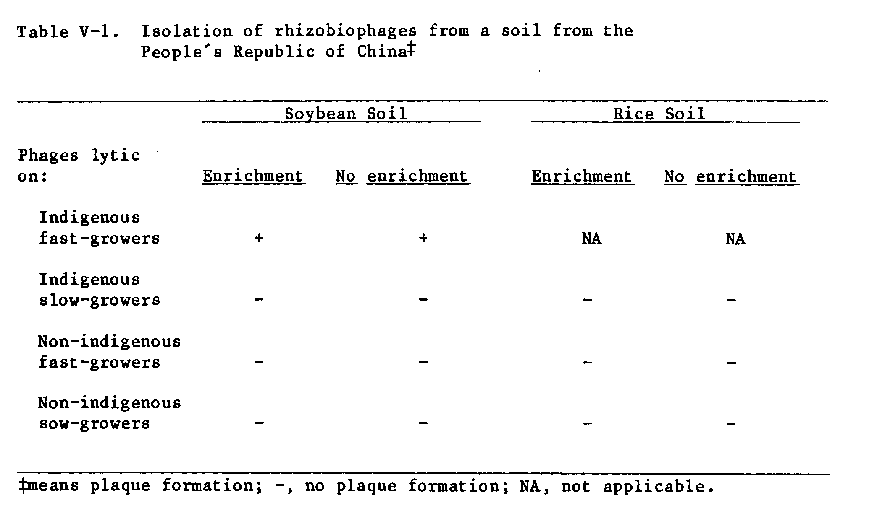
88 nm long with a base plate structure at the end of the tail (Figure V-la); phage HH102 exhibited an icosahedral head 42 ran in diameter and a stub tail 10 nm long with no structure visible at the end of the tail (Figure V-lb); phage HH003 was characterized by an icosahedral head 56 nm in diameter with a stub tail 10 nm long with a base-plate-like structure at the end of the tail (Figure V-lc); and phage HH402 revealed an icosahedral head 36 nm in diameter and no tail (Figure V-1d).
There were at least three distinct plaque morphologies as shown in Figure V-2. Phage HH303h formed 2 mm diameter clear plaques with distinct boundaries; phage HH 204 formed 5 mm diameter clear plaques with distinct boundaries; and phage HH504 formed 6 mm diameter plaques with a turbid center surrounded by a hazy zone with less distinct edges.
In total, seven phages were isolated and all were tested on different strains of Rhizobium from several different Rhizobium species. The host range of the phages was limited to fast-growing R. japonicum strains in the Honghu soil (Table V-2). None of the slow-growing R. japonicum strains tested were sensitive to any of the phages.
When 41 of the fast-growing isolates from the Honghu soil were tested for phage sensitivity in a phage-typing scheme, they were separated into seven phage-sensitivity groups (Table V-3). In general, the phages were very specific and had a narrow host range. Four of the fast-growing Honghu isolates were lysogenic and were not included in the phage-typing experiment. The plating procedure would induce the temperate phage to become lytic, and the control plates without added phage revealed plaques indicating the presence of prophage. This phenomenon is shown in Figure V-3 for strain USDA192.

Discussion

Phage morphology, as revealed by electron microscopy, was quite diverse. Phage HH102, with a short tail 10 nm long, was similar in morphology to the R. japonicum phages SB4 and SB5 described by Kowalski et al. (1974). All seven R. japonicum phages they examined were similar morphologically. Since there have been few reports concerning bacteriophages for slow-growing Rhizobium japonicum, the degree of diversity in this group is not known. Stacey et al. (1984) reported the bacteriophage TN1 that lyses R. japonicum 3Ilb110 had a long, contractile tail. The long-tail phages isolated in this study had distinct non-contractile tails similar to four groups of R. trifolii phages described by Barnett (1972). Phage HH402, the tail-less phage, was morphologically similar to rhizobiophage RS2 which lyses rhizobia from Sesbania (Lajudie and Bogusz, 1984).
Rhizobium host range of the phages in this study was limited to fast-growing soybean rhizobia. Reports have shown the host range for some rhizobiophages to cross taxonomic boundaries within related species of the Rhizobiaceae (Schwinghamer and Reinhardt, 1963; Kleczkowska, 1957; Napoli et al., 1980). The fast-growing soybean rhizobia are distinct in their biological and symbiotic properties from the slow-growing R. japonicum (Keyser et al., 1985), and although they appear to be related biochemically to other fast-growing species of Rhizobium (Sadowsky et al., 1983) they do not nodulate the hosts of the other fast-growing species R. melitoti; R. trifolii; R. phaseoli; R. leguminosarum (Keyser et al., 1982). The narrow host range of the rhizobiophages for the fast-growers in this study is a further indication that the fast-growing soybean rhizobia represent a unique addition to the Rhizobium germplasm.
The phage-typing scheme in this study revealed a relatively high degree of host specificity. Not surprisingly, the seven phage sensitivity groups showed little correlation with the IAR grouping (see Chapter III) which was used to select the isolates used to enrich for the phages. Grouping the isolates according to IAR proved a valuable tool when dealing with a relatively large group of unknown rhizobia. Phage typing slow-growing R. japonicum was more specific than the serological test (Kowalski, et al., 1974) and may be a valuable tool to further differentiate rhizobia within a single serogroup.
In the Honghu soybean soil, the relative abundance of rhizobiophages for the fast-growing rhizobia raises the question of the influence phages may have on the rhizobial population. Although the soybean soil contained both fast-and slow-growing rhizobia, phages were detected for the fast-growing rhizobia only. In addition, 100% of the nodules on soybeans growing in this soil were occupied by fast-growing rhizobia. This is evidence against an ecological role of phages in determining competition.
The localized concentration of phage on roots, nodules, and in soil surrounding the roots (Kleczkowska, 1957), where the population of host rhizobia is most concentrated, may be interpreted to represent a potential to have a selective influence on rhizobial populations. That such a selective influence is possible is underscored by the host specificity of rhizobiophages. However, there have been no reports which combine serology and phage sensitivity to examine the influence of phages on the strain composition of the rhizobial population. Kowalski et al. (1974) reported that among 51 R. japonicum-phage isolates, 45 lysed only rhizobial strains from the same serological group as the strain on which the phage was isolated. They suggested that a R. japonicum-phage test could be developed and used as an indicator for the distribution of a serological group of rhizobia. A similar application may be possible in order to detect the distribution of fast-growers in China. No data are available concerning the occurrence or distribution of rhizobiophages for fast-growing soybean rhizobia in soils in China.

Acknowledgment

I thank Dr. Richard Allen of the Pacific Biomedical Research Center, Univ. Hawaii for his assistance in preparing samples for electron microscopy.
Literature Cited

Adams, M.H. 1959. Bacteriophages. Interscience, New York.

Almon, L., and P.W. Wilson. 1933. Bacteriophage in relation to nitrogen fixation by red clover. Arch. Mikrobiol. 4:209-219.

Barnett, Y.M. 1972. Bacteriophages of Rhizobium trifolii I. Morphology and host range. J. Gen. Virol. 15:1-15.

Bruch, C.W., and O.N. Allen. 1955. Description of two bacteriophages active against Lotus rhizobia. Soil Sci. Soc. Am. Proc. 19:175-179.

Conn, H.J., E.J. Bottcher, and C. Randall. 1945. The value of bacteriophage in classifying certain soil bacteria. J. Bacteriol. 49:359-373.

De Lajudie, P., and D. Bogusz. 1984. Isolation and characterization of two bacteriophages of a stem-modulating Rhizobium strain from Sesbania rostrata. Can. J. Microbiol. 30:521-525.

Demolon, A., and A. Dunez. 1935. Research on the role of bacteriophage in the fatigue of lucerne soils. Ann. Agron. (New Series) 5:51-71.

Evans, J., Y.M. Barnet, and J.M. Vincent. 1979. Effect of a bacteriophage on the colonisation and nodulation of clover roots by a strain of Rhizobium trifolii. Can. J. Microbiol. 25:968-973.

Joseph, M.V., J.D. Desai, and A.J. Desai. 1985. Possible involvement of phage-like structures in antagonism of cowpea rhizobia by Rhizobium trifolii. Appl. Environ. Microbiol. 49:459-461.

Katznelson, H., and J.K. Wilson. 1941. Occurrence of Rhizobium meliloti bacteriophage in soils. Soil Sci. 51:59-63.

Keyser, H.H., B.B. Bohlool, T.S. Hu, and D.F. Weber. 1982. Fast-growing rhizobia isolated from root nodules of soybean. Science 215:1631-1632.

Keyser, H.H., M.J. Sadowsky, and B.B. Bohlool. 1985. Fast-growing soybean rhizobia. In R. Schibles (ed.), World soybean research conference III: proceedings, Westview Press, Boulder.

Kleczkowska, J. 1945. A quantitative study of the interaction of bacteriophage with Rhizobium using the technique of poured plates. J. Bacteriol. 50:81-94.

Kleczkowska, J. 1950. A study of phage-resistant mutants of Rhizobium trifolii. J. Gen. Microbiol. 4:298-310.

Kleczkowska, J. 1957. A study of the distribution and the effects of bacteriophage of root nodule bacteria in the soil. Can. J. Microbiol. 3:171-180.
Kowalski, M., G.E. Ham, L.R. Frederick, and I.C. Anderson. 1974. Relationship between strains of Rhizobium japonicum and their bacteriophages from soil and nodules of field-grown soybeans. Soil Sci. 118:221-228.

Laird, D.G. 1932. Bacteriophage and root nodule bacteria. Arch. Mikrobiol. 3:159-193.

Lotz, W., and F. Mayer. 1972. Isolation and characterization of a bacteriophage tail-like bacteriocin from a strain of Rhizobium. J. Virol. 9:160-173.

Napoli, C.A., R. Sanders, R. Carlson, and P. Albersheim. 1980. Hostsymbiont interaction:recognizing Rhizobium, p. 189-203. In W.E. Newton and W.H. Orme-Johnson (eds.) Nitrogen Fixation, vol. II. University Park Press, Baltimore.

Sadowsky, M.J., H.H. Keyser, and B.B. Bohlool. 1983. Biochemical characterization of fast-and slow-growing rhizobia that nodulate soybeans. Int. J. Sys. Bacteriol. 33:716-722.

Schwinghamer, E.A., and J. Brockwell. 1978. Competitive advantage of bacteriocin-and phage-producing strain of Rhizobium trifolii in mixed culture. Soil Biol. Biochem. 10:383-387.

Schwinghamer, E.A., and D.J. Reinhardt. 1963. Lysogeny in Rhizobium leguminosarum and Rh. trifolii. Aust. J. Biol. Sci. 16:597-605.

Schwinghamer, E.A., C.E. Pankhurst, and P.R. Whitfeld. 1973. A phage-like bacteriocin of Rhizobium trifolii. Can. J. Microbiol. 19:359-368.

Stacey, G., L.A. Pocratsky, and V. Puvanesarajah. 1984. Bacteriophage that can distinguish between wild-type Rhizobium japonicum and a non-nodulationg mutant. Appl. Environ. Microbiol. 48:68-72.

Vincent, J.M. 1970. A manual for the practical study of root-nodule bacteria. IBP handbook 15. Blackwell Scientific Publications, Oxford.

Vincent, J.M. 1977. Rhizobium: general microbiology. p. 277-366. In R.W.F. Hardy and W.S. Silver (eds.), A Treatise On Dinitrogen Fixation, Section III. John Wiley & Sons, New York.
CHAPTER VI
GENERAL DISCUSSION

The results presented in this dissertation have several implications for the practical application of rhizobial inoculants on soybeans and on future research on the soybean symbiosis.
The results of Chapter II indicate that the competitive success of rhizobial inoculants is influenced by the number of rhizobia in the inoculum and the cropping system. In the presence of effective, indigenous rhizobia the response to inoculation could not be measured by plant parameters (such as nitrogen content, seed yield, etc.); rather, the response was quantified by serotyping nodules with strain-specific fluorescent antibodies. Although R. japonicum survived in flooded soil, nodule occupancy of soybeans following flooded rice was affected by inoculation. In this particular soil, the indigenous rhizobia were effective, but in a soil with ineffective indigenous rhizobia there is reason to believe that inoculation of soybeans following rice may result in increased soybean yields. This is an area of research that deserves more attention.
The predominance of fast-growing rhizobia in nodules on soybeans growing in the Honghu soybean soil described in Chapter III raises several questions. The frequency of occurrence of fast-growers in Chinese soils and their competition with inoculum rhizobia is unknown. Surveys to determine the range of fast-growers in China would be welcome. The competition studies described in Chapter IV suggest that the fast-growers are successful competitors when they are indigenous bacteria, as well as under other circumstances such as those imposed in the Wuhan rice soil.
One proposed solution to the problem of competition is to find a cultivar-strain combination that would exclude any other strains from forming nodules on the cultivar. In these data, with respect to symbiotic efficiency, there was-more cultivar-strain interaction among the fast-growers than with the slow-growers. A more detailed knowledge of the genetics of the symbiosis would undoubtedly be helpful in discovering or engineering an exclusive cultivar-strain symbiosis. The bacteriphages described in Chapter V may prove useful for developing a tool for the study of the genetics of the soybean symbiosis.
The data presented in this dissertation are the result of an extended stay in China. The primary motivation for working in China was to work in the center of origin of soybeans with the possibility of encountering new soybean and rhizobial germplasm. It was an exciting prospect, and the results will hopefully contribute to the pool of knowledge on the Rhizobium-soybean symbiosis.
